|  | **MINISTRY OF EDUCATION AND TRAINING** |
| --- | --- |

| **FPT UNIVERSITY** |
| --- |
| Capstone Project Document |
| Blind Box Trade and Sell System - BlindB!ox |

| **BlindB!ox** | |
| --- | --- |
| **Group Members** | Trương Minh Phước - SE184067  Phan Cảnh Bảo Duy - SE184173  Nguyễn Đông Giang - SE183728  Nguyễn Lê Khôi - SE183712  Đỗ Nguyễn Mỹ Anh - SE183823 |
| **Supervisor** | Nguyễn Ngọc Lâm |

- Ho Chi Minh, 02/2025-

**Table of Contents**

Acknowledgement 4

Definition and Acronyms 4

I. Project Introduction 5

1. Overview 5

2. Product Background 5

3. Existing Systems 5

4. Business Opportunity 5

5. Software Product Vision 5

6. Project Scope & Limitations 5

II. Project Management Plan 6

1. Overview 6

2. Management Approach 6

3. Master Schedule 6

4. Project Organization 6

5. Project Communication 6

6. Configuration Management 6

III. Software Requirement Specification 7

1. Overall Description 7

2. User Requirements 7

3. Functional Requirements 7

4. Non-Functional Requirements 7

5. Other Requirements 7

IV. Software Design Description 8

1. Overall Description 8

2. System Architecture Design 8

3. System Detailed Design 8

4. Class Specification 8

5. Data & Database Design 8

V. Software Testing Documentation 9

1. Overall Description 9

2. Test Plan 9

3. Test Cases 9

4. Test Reports 9

VI. Release Package & User Guides 10

1. Deliverable Package 10

2. Installation Guides 10

3. User Manual 10

VII. Appendix 10

1. Glossary [Optional] 10

2. References [Optional] 10

3. Others [Optional] 10

# Definition and Acronyms

| **Acronym** | **Definition** |
| --- | --- |
| API | Application Program Interface |
| BE | Backend |
| BR | Business Rule |
| FE | Frontend |
| CR | Common Requirement |
| ERD | Entity Relationship Diagram |
| LI | Limitations |
| SDD | Software Design Description |
| SPMP | Software Project Management Plan |
| SRS | Software Requirement Specification |
| UC | Use Case |
| UI | User Interface |

Table 1. Definition and Acronyms

# 

# 

# 

# 

# 

# I. Project Introduction

At Blind Box Trade and Sell System - BlindB!ox, we are transforming the way people buy, sell, and exchange collectibles by fostering a thriving community of blind box enthusiasts. Our platform provides a user-friendly and secure marketplace that ensures smooth connections for all participants.

Our marketplace system encourages users to manage their product wisely while guaranteeing equitable access to trading opportunities. We establish a vibrant marketplace that improves user satisfaction and encourages blind box enthusiasts to grow by streamlining the trading and selling process.

## 1. Overview (Phước)

### 1.1 Project Information

* Project Name: Blind Box Trade and Sell System - BlindB!ox
* Group Name:
* Software type: Web Application, Mobile Application

### 1.2 Project Team

1. *Supervisor*

| Full Name | Email | Phone Number | Title |
| --- | --- | --- | --- |
| Nguyễn Ngọc Lâm | lamnn15@fe.edu.vn |  | Lecture |

Table 2. Supervisor

1. *Team members*

| Full Name | Email | Phone Number | Title |
| --- | --- | --- | --- |
| Trương Minh Phước | phuoctmse184067@fpt.edu.vn |  | Leader |
| Phan Cảnh Bảo Duy | duypcbse184173@fpt.edu.vn |  | Member |
| Nguyễn Đông Giang | giangnd183728@fpt.edu.vn |  | Member |
| Nguyễn Lê Khôi | khoinl183712@fpt.edu.vn |  | Member |
| Đỗ Nguyễn Mỹ Anh | anhdnmse183823@fpt.edu.vn |  | Member |

Table 3. Team members

## 2. Product Background (Phước)

In recent years, the blind box market has grown rapidly, with a strong demand for rare and collectible items. Enthusiasts often seek specific pieces to complete their collections, leading to an increasing need for a structured marketplace where users can not only buy and sell but also trade with others. Recognizing this gap, our platform provides a seamless way for collectors to connect, negotiate, and exchange items, enhancing the overall experience of blind box collecting.

## 3. Existing Systems (Duy)

**3.1 Manual Solution**

Before an online platform, users rely on manual methods for trading blind box collectibles, which are often inefficient and insecure. One of them are:

#### Social Media Platforms: Trade via Facebook groups, Instagram, and other messaging platforms. Traders have to accept fraud risk with no integrated payments…

* In-person Meetups: Local collector communities often organized meetups at conventions, toy fairs, or public spaces to facilitate trades.
* Online Forums & Marketplaces: Some collectors turned to specialized forums (such as Shopee, Lazada, or Toysphere) to list and trade items. While marketplaces like shopee provided buyer protection, they often came with high fees, slow dispute resolution, and limitations on direct trading between users.

**3.2 Bemori (Phước)**

Bemori is a plush toy brand that aims to create meaningful gifting experiences. With its slogan "Hug Teddy – Unbox Love," Bemori focuses on delivering emotions through its products.

Feature:

* Product listing with detailed descriptions and images: Helps users make informed purchasing decisions.
* E-commerce integration: Enables seamless online purchasing.
* Emphasis on branding and storytelling: Enhances user engagement through emotional connection with products.

Cons:

* No trading functionality: Bemori is a direct-to-consumer sales platform, lacking a peer-to-peer trading mechanism.
* Limited seller participation: Only Bemori sells products, unlike our open marketplace model that allows multiple sellers.
* No admin-controlled trade approvals: The system is not designed to moderate user-generated trading content.

Reference: <https://bemori.vn/>

## 4. Business Opportunity (Duy)

## Blindbox marketplace is expanding rapidly, with collectors actively searching for a better way to buy, sell, and trade their items. But existing platforms such as social media groups like Facebook, Twitter, or e-commerce sites lack dedicated trade management, secure transactions, and fair valuation tools, which lead to trust issues and inefficient trades. BlindB!ox provides a specialized marketplace for traders and sellers, ensuring secure transactions, trade approvals, and transparent trading. By solving these main points, the platform will create a potential market opportunity, attracting collectors who want a user-friendly and fair trading experience.

## 5. Project Scope & Limitations (Duy)

#### 5.1 Project Scope

### Buyer

* Browse & Customize Products
* Place Orders & Make Secure Payments
* Apply Promo Codes
* Track Orders & Delivery
* Leave Reviews

### Seller

* Create & Manage Selling Posts
* Upload Product Details & Prices
* Manage Inventory & Orders
* Monitor Shipping & Feedback

### Trader

* Purchase Trade Credits
* Create & Manage Trade Posts
* Search & Propose Trades
* Accept Offers & Balance Trades

### Admin

* Manage Users & Content
* Approve & Moderate Posts
* Enforce Policies & Guidelines
* Monitor System & Handle Disputes

#### 5.2 Limitations

**Geographic Restrictions**

* The platform may initially operate in selected regions only.
* Shipping and delivery services may not be available worldwide.

**Payment Constraints**

* Only specific payment gateways may be supported based on regional availability.
* Transaction fees may apply for certain payment options.

**Trade System Limitations**

* Users must follow predefined rules for trade proposals and acceptances.
* Admin approval is required before trade posts go live.

**Stock & Availability**

* Sellers are responsible for updating stock availability.
* System may experience delays in reflecting real-time stock changes.

**Security & Moderation**

* While the platform enforces strict security policies, 100% fraud prevention cannot be guaranteed.
* Disputes will be resolved based on platform policies, but external resolution may be required in complex cases.

# 

# II. Project Management Plan (Phước)

| **No** | **Task** | **Member** | **Finished Week** |
| --- | --- | --- | --- |
| 1 | Project Introduction | Minh Phước  Bảo Duy | Week 3 |
| 2 | Use Case Diagram  Database Design | All Members | Week 5  Week 6 |
| 3 | Functional Requirements, Non-Functional Requirements | Bảo Duy | Week 4 |
| 4 | System Architecture | Minh Phước | Week 4 |
| 5 | Screen Flow | Đông Giang | Week 6 |
| 6 | Package Diagram | Minh Phước  Đông Giang | Week 7 |
| 7 | Activity Diagram | Mỹ Anh  Lê Khôi | Week 5 |
| 8 | Sequence Diagram | Minh Phước | Week 6 |
| 9 | State Diagram | Minh Phước | Week 5 |
| 10 | Finalize Document | All Members | Week 7 |
| 11 | Front End | Đông Giang  Lê Khôi  Mỹ Anh | Week 1 |
| 12 | Back End | Minh Phước  Bảo Duy | Week 1 |

*Table. Document effort estimation*

| **No** | **Task** | **Estimate (days)** |
| --- | --- | --- |
| **1** | **Week 1 , Week 2, Week 3** | **21** |
| 1.1 | Learning and research | 20 |
| 1.1.1 | Learning Express JS, Rest API, MongoDB, Typescript | 12 |
| 1.1.2 | Learning React | 8 |
| 1.2 | Knowledge transfer coding convention, API convention | 1 |
| **2** | **Week 4** | **6** |
| 2.1 | Design UI | 4 |
| 2.2 | Set up environment | 2 |
| 2.2.1 | Set up front end environment | 1 |
| 2.2.2 | Set up back end environment | 1 |
| **3** | **Week 5, Week 6** | **14** |
| 3.1 | Confirm database design | 5 |
| 3.2 | Implement authorize flow | 9 |
| 3.2.1 | Hotfix authorize flow bugs | 4 |
| 3.2.2 | Build API for authorize flow | 4 |
| 3.3 | Test API | 1 |
| **4** | **Week 7, Week 8, Week 9** | **21** |
| 4.1 | Implement buy and sell flow | 10 |
| 4.1.1 | Build API for buy and sell flow | 9 |
| 4.1.2 | Test API | 1 |
| 4.2 | Implement trade flow | 11 |
| 4.2.1 | Build API for trade flow | 10 |
| 4.2.2 | Test API | 1 |
| **5** | **Week 10** | **2** |
| 5.1 | Finalize BlindB!ox system | 1 |
| 5.2 | Prepare slide presentation | 1 |

***Total days : 64***

*Table. Development effort estimation*

# III. Software Requirement Specification

## 1. Product Overview (Duy)

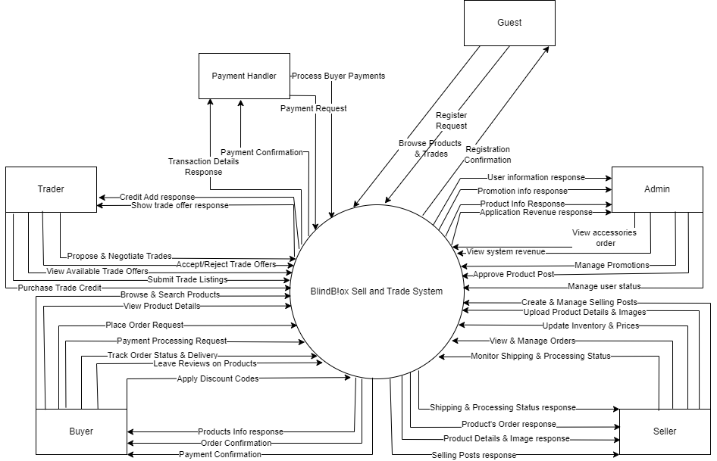

**1.1 Buyer Requirements**

Buyer is the person who buys products from the application. There are some functions that buyer can do

* Browse Accessories & Blind Box Products
* View Product Details & Customize Accessories
* Place Orders for Available Products
* Secure Payments via Multiple Methods
* Apply Platform-Provided Promo Codes
* Track Order Status & Delivery Updates
* Leave Reviews

**1.2 Seller Requirements**

A seller is a user who lists blind box products and accessories for sale on the platform. Functions that seller can do are:

* Create & Manage Selling Posts
* Upload Product Details, Prices, and Images
* Track & Update Product quantity
* View & Manage Incoming Orders
* Monitor Shipping & Processing Status
* Respond to Buyer Reviews & Feedback

**1.3 Trader Requirements**

A trader is a user who exchanges unboxed collectibles with other users via the platform and get contact with other traders.

* Purchase Trade Credits for Exchanges
* Create Trade Posts for Unboxed Items
* Get Trade Posts Approved by Admin
* View & Search Available Trade Listings
* Propose Trades to Other Users
* Review & Accept Trade Offers
* Add Multiple Items or Cash to Balance Trades

**1.4 Admin Requirements**

An admin is responsible for maintaining platform integrity, ensuring a safe and fair trading environment for all users

* Manage User Accounts
* Moderate User Posts, Reviews, and Messages
* Approve & Reject Trade & Selling Posts
* Enforce Platform Policies & Community Guidelines
* Monitor System KPIs & Financial Performance
* Handle Flagged Issues & Disputes

## 2. User Requirements (All Members)

### 2.1 Actors & Roles

| No | Actor | Description |
| --- | --- | --- |
| 1 | Unauthenticated User | Users have not logged into BlindB!ox |
| 2 | Authenticated User | Users have logged into BlindB!ox |
| 3 | Buyer | User has logged into BlindB!ox as “User” role |
| 4 | Seller | User has logged into BlindB!ox as “User” role |
| 5 | Trader | User has logged into BlindB!ox as “User” role |
| 6 | Admin | User has logged into BlindB!ox as “Admin” role |

* **Buyer** – Purchases products, applies promo codes, tracks orders, and leaves reviews.
* **Seller** – Lists products, manages inventory and orders, and responds to buyer feedback.
* **Trader** – Posts trade offers, browses available trades, and finalizes exchanges.
* **Admin** – Manages user accounts, moderates content, and oversees platform activities.

### 2.2 Use Case Diagram

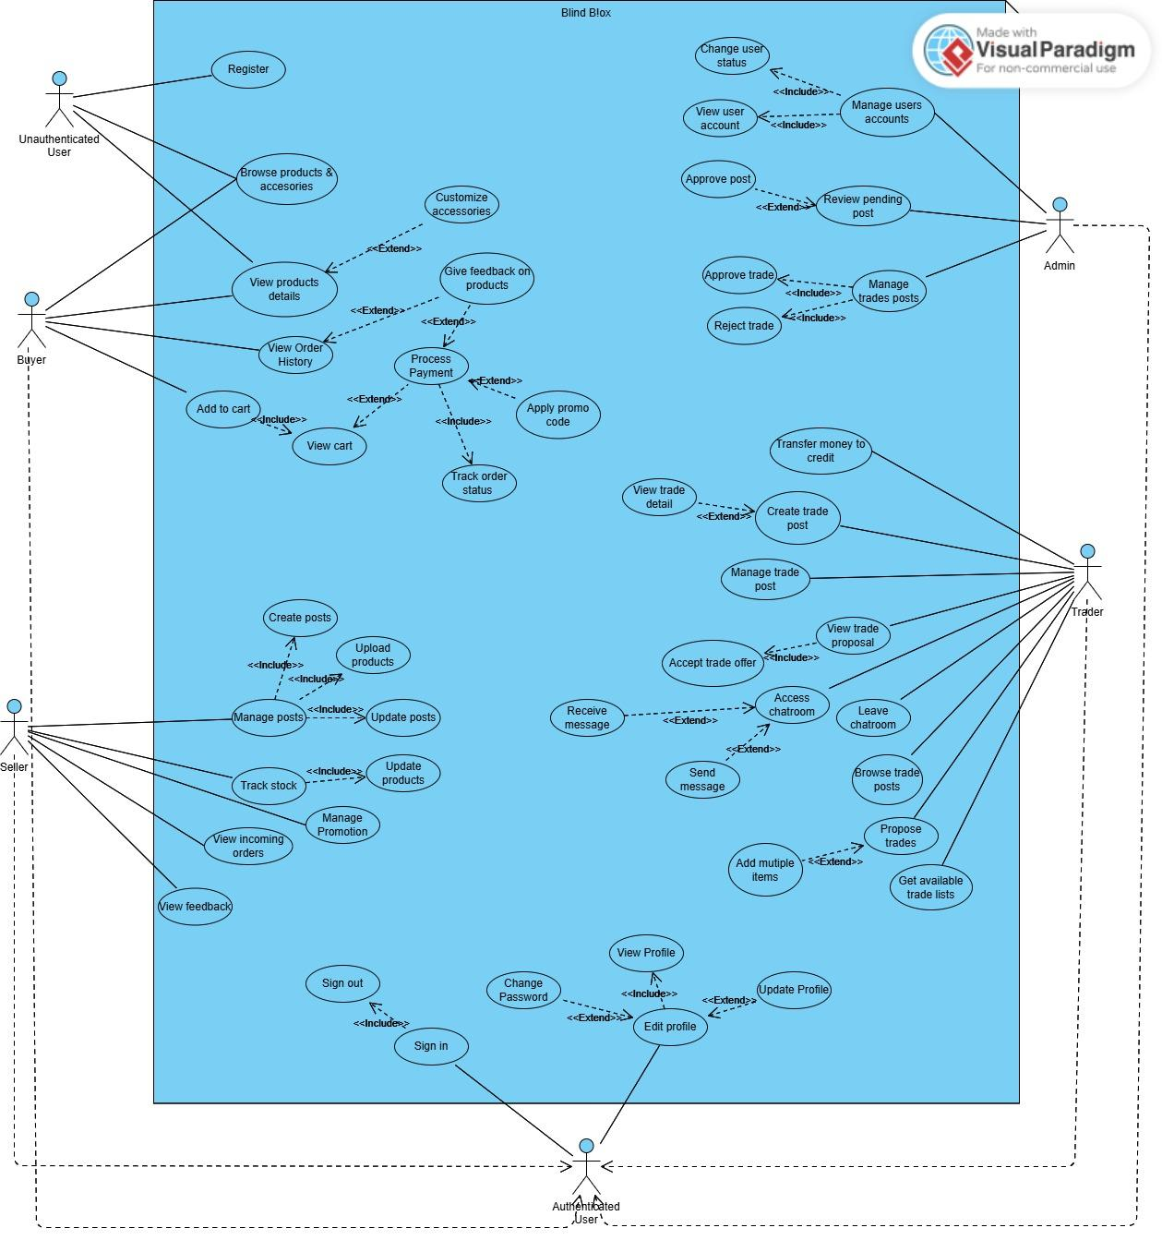

| # | Use Case | Actors | Description | Assignee |
| --- | --- | --- | --- | --- |
| UC-01 | Sign in | Buyer, Seller, Trader, Admin | Users can log in to the system by entering their account information. | Bảo Duy |
| UC-02 | Register | Unauthenticate user | Users can create a new account by providing necessary personal and account information. | Bảo Duy |
| UC-03 | Browse products & accessories | Buyer | Buyers can browse and view the details of blind box products and accessories available on the platform. | Bảo Duy |
| UC-04 | View products details | Buyer, Seller, Admin | Allows buyers to view detailed information about a selected blind box product or accessory, including images, descriptions, prices, … | Bảo Duy |
| UC-05 | Customize accessories | Buyer | Buyers can customize accessories with different options such as color, size, and add it to the blindbox products. | Bảo Duy |
| UC-06 | Add to cart | Buyer | Buyers can add items to their shopping cart for future purchase. | Bảo Duy |
| UC-07 | View cart | Buyer | Buyers can view the items they have added to their shopping cart. | Bảo Duy |
| UC-08 | Process Payment | Buyer | Buyers can process payment for the items in their shopping cart to complete a purchase. | Bảo Duy |
| UC-09 | Apply promo code | Buyer | A buyer can apply a promo code during checkout to receive a discount or special offer.. | Mỹ Anh |
| UC-10 | Track order status | Buyer | A buyer can track the status of their order after placing a purchase. | Mỹ Anh |
| UC-11 | Give feedback on products | Buyer | A buyer can leave feedback and rate products they have purchased. | Mỹ Anh |
| UC-12 | Upload products | Seller | A seller can upload new products to the marketplace. | Mỹ Anh |
| UC-13 | Update products | Seller | A seller can update product details, including price, description, images, and availability. | Mỹ Anh |
| UC-14 | Delete products | Seller | A seller can delete products from their inventory, removing them from the marketplace. | Mỹ Anh |
| UC-15 | View incoming orders | Seller | This use case allows sellers to view incoming orders , including order details, buyer information, and order status | Minh Phước |
| UC-16 | Manage Promotion | Seller | Sellers can create, edit, and manage promotional offers for their products to enhance sales and attract more buyers. | Minh Phước |
| UC-17 | View feedback | Seller, Buyer | Allows sellers to view feedbacks left by buyers on their products | Minh Phước |
| UC-18 | View user account | Admin | Admin allows to view their account details, including profile information | Minh Phước |
| UC-19 | Change user status | Admin | Admins can change the status of users to unverified, active, or banned to manage user activities and maintain platform security. | Minh Phước |
| UC-20 | Review pending post | Admin | Admin allows to review sellers ‘s pending posts before they go live on the platform | Minh Phước |
| UC-21 | Approve post | Admin | Admin can approve trade posts from users to publish on the platform. | Đông Giang |
| UC-22 | Transfer money to credit | Trader | The Trader subscribes to a credit plan | Đông Giang |
| UC-23 | Create trade post | Trader | The trader wants to list an item for trade. | Đông Giang |
| UC-24 | View trade detail | Trader | A trader can view detailed information about a trade post. | Đông Giang |
| UC-25 | Update trade post | Trader | Trader updates the details of an existing trade post. | Đông Giang |
| UC-26 | View trade proposal | Trader | Trader views trade proposals submitted by other users. | Đông Giang |
| UC-27 | Accept trade offer | Trader | Traders can accept trade offers made by other users on the platform. | Lê Khôi |
| UC-28 | Browse trade posts | Trader, Admin | Traders can browse available trade posts listed that have been approved by Admin. | Lê Khôi |
| UC-29 | Propose trades | Trader | Traders can initiate trade proposals with other users based on their listed trade posts. | Lê Khôi |
| UC-30 | Get available trade lists | Trader | Traders can view all available trade listings to assess potential trades. | Lê Khôi |
| UC-31 | Sign out | Buyer, Seller, Trader, Admin | User can log out from the application | Bảo Duy |
| UC-32 | Change Password | Buyer, Seller, Trader, Admin | User can change their account password | Bảo Duy |
| UC-33 | Update Profile | Buyer, Seller, Trader, Admin | User can update their information for buying and receiving products. | Bảo Duy |

**2.2.1 UC-01 Login**

| **Use Case Specification** | | | |
| --- | --- | --- | --- |
| **Use Case No.:** | UC-01 | | |
| **Use Case Name:** | Login | | |
| **Created By:** | Bao Duy | | |
| **Date:** | 20/02/2025 | **Priority:** | High |
| **Actors:** | Buyer, Seller, Trader, Admin | | |
| **Summary:** | Users can log in to the system by entering their account information. | | |
| **Trigger:** | The user wants to access their account and enters the login page to authenticate. | | |
| **Preconditions:** | 1. The system must be operational. 2. The user must have an existing account on the system. | | |
| **Post–conditions:** | 1. If successful, the user is logged into their account and redirected to their dashboard. 2. If unsuccessful, an error message is displayed, explaining the reason for the failure (e.g., incorrect password, account not found). | | |
| **Main Success Scenario/Main Flow/Normal Flow/Main Path:**   | **Step.** | **Actor Action** | **System Response** | | --- | --- | --- | | 1 | The user navigates to the login page. | The system displays the login form. | | 2 | The user enters their username and password and clicks the "Login" button. | The system validates the entered information. | | 3 | (Happy Path) The credentials are correct. | The system logs the user in and redirects them to their dashboard. | | | | |
| **Alternative Flows:**   | **No.** | **Actor Action** | **System Response** | | --- | --- | --- | | 1 | The user enters incorrect credentials. | The system displays an error message indicating incorrect username or password. | | | | |
| **Exceptions:**   | **No.** | **Actor Action** | **System Response** | | --- | --- | --- | | 1 | The user has forgotten their password and clicks the "Forgot Password" link. | The system redirects the user to the password recovery page. | | | | |
| **Business Rules:** | 1. The username must be unique and not already in use by another account. 2. Passwords must be at least 8 characters long and contain a mix of upper and lower case letters, digits, and special characters. 3. Usernames and emails must be validated to ensure they are in the correct format before submission. | | |

**2.2.2 UC-02 Register**

| **Use Case Specification** | | | |
| --- | --- | --- | --- |
| **Use Case No.:** | UC-02 | | |
| **Use Case Name:** | Register | | |
| **Created By:** | Bao Duy | | |
| **Date:** | 20/02/2025 | **Priority:** | High |
| **Actors:** | Buyer, Seller, Trader, Admin | | |
| **Summary:** | Users can create a new account by providing necessary personal and account information. | | |
| **Trigger:** | A new user wants to create an account to access the system's functionalities and initiates the registration process. | | |
| **Preconditions:** | 1. The system must be operational. 2. The user must have a valid email address and access to it. | | |
| **Post–conditions:** | 1. If successful, the user's account is created, and they are redirected to the login page with a success message. 2. If unsuccessful, the system displays an error message explaining the reason for failure (e.g., email already taken, invalid input). | | |
| **Main Success Scenario/Main Flow/Normal Flow/Main Path:**   | **Step.** | **Actor Action** | **System Response** | | --- | --- | --- | | 1 | The user navigates to the registration page. | The system displays the registration form. | | 2 | The user enters their personal information (e.g., name, email, password) and clicks the "Register" button. | The system validates the entered information. | | 3 | The entered details are correct and meet validation criteria. | The system creates the user account and displays a success message. | | 4 | The user is redirected to the login page. | The system awaits further actions( user login, …). | | | | |
| **Alternative Flows:**   | **No.** | **Actor Action** | **System Response** | | --- | --- | --- | | 1 | The user enters an email that is already in use. | The system displays an error message indicating the email is already taken. | | 2 | The user provides invalid information (e.g., weak password, missing fields). | The system displays an error message indicating the issue and prompts for corrections. | | | | |
| **Exceptions:**   | **No.** | **Actor Action** | **System Response** | | --- | --- | --- | | 1 | The user fails to receive the confirmation email. | The system allows resending of the confirmation email. | | | | |
| **Business Rules:** | 1. The email address must be unique and not already in use by another account. 2. Passwords must be at least 8 characters long and contain a mix of upper and lower case letters, digits, and special characters. 3. Usernames and emails must be validated to ensure they are in the correct format before submission. 4. The user must agree to the terms and conditions before account creation. | | |

**2.2.3 UC-03 Browse Blindbox Products & Accessories**

| **Use Case Specification** | | | |
| --- | --- | --- | --- |
| **Use Case No.:** | UC-03 | | |
| **Use Case Name:** | Browse Blindbox Products & Accessories | | |
| **Created By:** | Bao Duy | | |
| **Date:** | 20/02/2025 | **Priority:** | Medium |
| **Actors:** | Buyer | | |
| **Summary:** | Buyers can browse and view the details of blind box products and accessories available on the platform. | | |
| **Trigger:** | A buyer wants to explore the available blind box products and accessories to make a purchase. | | |
| **Preconditions:** | 1. The system must be operational. 2. The buyer must be logged into the platform. | | |
| **Post–conditions:** | 1. If successful, the buyer can view detailed information about available products and accessories and proceed to the next steps for purchasing. 2. If unsuccessful, the buyer is informed of any issues preventing the browsing of products. | | |
| **Main Success Scenario/Main Flow/Normal Flow/Main Path:**   | **Step.** | **Actor Action** | **System Response** | | --- | --- | --- | | 1 | The buyer logs into their account on the platform. | The system authenticates the buyer and displays their dashboard. | | 2 | The buyer navigates to the "Products" section. | The system displays a list of available blind box products and accessories. | | 3 | The buyer selects a product or accessory to view its details. | The system shows detailed information about the selected item, including images, prices, and descriptions. | | 4 | The buyer can filter and sort products based on various criteria (e.g., category, price, popularity). | The system updates the product list based on the selected filters and sorting preferences. | | 5 | The buyer can customize selected accessories. | The system provides options to customize accessories and updates the product display accordingly. | | | | |
| **Alternative Flows:**   | **No.** | **Actor Action** | **System Response** | | --- | --- | --- | | 1 | The buyer cannot find the desired product. | The system provides search functionality to help locate the product. | | 2 | The buyer encounters an issue with filtering or sorting. | The system displays an error message and suggests corrective actions. | | | | |
| **Exceptions:**   | **No.** | **Actor Action** | **System Response** | | --- | --- | --- | | 1 | The buyer experiences a system error or downtime while browsing. | The system displays an error message and prompts the buyer to try again later. | | | | |
| **Business Rules:** | 1. Product information and availability must be regularly updated to reflect current stock and offerings. 2. The system must provide accurate and up-to-date pricing and promotional information. 3. Filters and sorting options should be intuitive and comprehensive to enhance the browsing experience. | | |

**2.2.5 UC-04 View Product Details**

| **Use Case Specification** | | | |
| --- | --- | --- | --- |
| **Use Case No.:** | UC-04 | | |
| **Use Case Name:** | View Product Details | | |
| **Created By:** | Bao Duy | | |
| **Date:** | 20/02/2025 | **Priority:** | High |
| **Actors:** | Buyer | | |
| **Summary:** | This use case allows buyers to view detailed information about a selected blind box product or accessory, including images, descriptions, prices, and customization options. | | |
| **Trigger:** | A buyer wants to get more information about a product they are interested in. | | |
| **Preconditions:** | 1. The buyer must be logged into their account on the platform. 2. The product must be listed and available on the platform. | | |
| **Post–conditions:** | 1. If successful, the buyer will see detailed information about the selected product. 2. If unsuccessful, the buyer is informed of any issues that prevent viewing the product details. | | |
| **Main Success Scenario/Main Flow/Normal Flow/Main Path:**   | **Step.** | **Actor Action** | **System Response** | | --- | --- | --- | | 1 | The buyer selects a product from the product list. | The system retrieves and displays detailed information about the product, including images, descriptions, prices, and available customization options. | | 2 | The buyer reviews the displayed product information. | The system presents options for the buyer to further interact with the product, such as customizing the accessory or adding the product to the cart. | | 3 | The buyer can choose to add the product to their cart. | The system adds the product to the buyer's cart and updates the cart information accordingly. | | | | |
| **Alternative Flows:**   | **No.** | **Actor Action** | **System Response** | | --- | --- | --- | | 1 | The buyer cannot find the desired product details. | The system provides search functionality to help locate the product and offers suggestions based on search input. | | 2 | The buyer selects a product that is out of stock. | The system displays an out-of-stock message and suggests similar products that are available. | | | | |
| **Exceptions:**   | **No.** | **Actor Action** | **System Response** | | --- | --- | --- | | 1 | The buyer experiences a system error or downtime while viewing product details. | The system displays an error message indicating the issue and prompts the buyer to try again later. | | | | |
| **Business Rules:** | 1. The system must ensure that all product information is accurate and up-to-date. 2. The system must securely handle and display all customization options available for a product. 3. The system must validate product availability before allowing the buyer to add the product to their cart. | | |

**2.2.4 UC-05 Customize accessories**

| **Use Case Specification** | | | |
| --- | --- | --- | --- |
| **Use Case No.:** | UC-05 | | |
| **Use Case Name:** | Customize accessories | | |
| **Created By:** | Bao Duy | | |
| **Date:** | 20/02/2025 | **Priority:** | Medium |
| **Actors:** | Buyer | | |
| **Summary:** | Buyers can customize accessories with different options such as color, size, and add it to the blindbox products. | | |
| **Trigger:** | The buyer chooses to customize an accessory from the product page. | | |
| **Preconditions:** | 1. The system must be operational. 2. The buyer must be logged into the system and browsing the product details page of an accessory. | | |
| **Post–conditions:** | 1. If successful, the customized accessory is added to the buyer's cart for purchase. 2. If unsuccessful, an error message is displayed, explaining the reason for the failure. | | |
| **Main Success Scenario/Main Flow/Normal Flow/Main Path:**   | **Step.** | **Actor Action** | **System Response** | | --- | --- | --- | | 1 | The buyer selects an accessory to customize. | The system displays customization options (e.g., color, size, engravings). | | 2 | The buyer modifies selections as desired. | The system updates the customization preview. | | 3 | The buyer previews the customized accessory. | The system displays a preview of the customized accessory. | | 4 | The buyer confirms changes. | The system updates the accessory in the cart with customizations. | | | | |
| **Alternative Flows:**   | **No.** | **Actor Action** | **System Response** | | --- | --- | --- | | 1 | The customization option is not available. | The system informs the buyer that the customization option is not available. | | | | |
| **Exceptions:**   | **No.** | **Actor Action** | **System Response** | | --- | --- | --- | | 1 | A system error occurs during customization | The system logs the error and informs the buyer to try again later. | | | | |
| **Business Rules:** | 1. The accessory must contain customizable options defined by the seller. 2. Customizations are final once confirmed by the buyer. | | |

**2.2.4 UC-06 Add to cart**

| **Use Case Specification** | | | |
| --- | --- | --- | --- |
| **Use Case No.:** | UC-06 | | |
| **Use Case Name:** | Add to cart | | |
| **Created By:** | Bao Duy | | |
| **Date:** | 20/02/2025 | **Priority:** | High |
| **Actors:** | Buyer | | |
| **Summary:** | Buyers can add items to their shopping cart for future purchase. | | |
| **Trigger:** | The buyer chooses to customize an accessory from the product page. | | |
| **Preconditions:** | 1. The system must be operational. 2. The buyer must be logged into the system. | | |
| **Post–conditions:** | 1. If successful, the selected item is added to the buyer's cart. 2. If unsuccessful, an error message is displayed, explaining the reason for the failure. | | |
| **Main Success Scenario/Main Flow/Normal Flow/Main Path:**   | **Step.** | **Actor Action** | **System Response** | | --- | --- | --- | | 1 | The buyer selects an item to buy | The system displays the product details page. | | 2 | The buyer clicks the "Add to Cart" button | The system validates the product availability. | | 3 | The product is available. | The system adds the product to the buyer's cart and confirms the addition. | | | | |
| **Alternative Flows:**   | **No.** | **Actor Action** | **System Response** | | --- | --- | --- | | 1 | The product is out of stock. | The system informs the buyer that the item is out of stock. | | | | |
| **Exceptions:**   | **No.** | **Actor Action** | **System Response** | | --- | --- | --- | | 1 | There is a system error during addition to cart. | The system logs the error and informs the buyer to try again later. | | | | |
| **Business Rules:** | 1. The system must check inventory levels before adding an item to the cart. 2. Items in the cart must be reserved for a limited time until checkout is completed. | | |

**2.2.4 UC-07 View cart**

| **Use Case Specification** | | | |
| --- | --- | --- | --- |
| **Use Case No.:** | UC-07 | | |
| **Use Case Name:** | View cart | | |
| **Created By:** | Bao Duy | | |
| **Date:** | 20/02/2025 | **Priority:** | High |
| **Actors:** | Buyer | | |
| **Summary:** | Buyers can view the items they have added to their shopping cart. | | |
| **Trigger:** | The buyer decides to view the contents of their cart by clicking on the "Cart" icon. | | |
| **Preconditions:** | 1. The system must be operational. 2. The buyer must be logged into the system. 3. The buyer has already added items to their cart. | | |
| **Post–conditions:** | 1. If successful, the buyer can see the list of items in their cart. 2. If unsuccessful, an error message is displayed, explaining the reason for the failure. | | |
| **Main Success Scenario/Main Flow/Normal Flow/Main Path:**   | **Step.** | **Actor Action** | **System Response** | | --- | --- | --- | | 1 | The buyer clicks on the "Cart" icon. | The system retrieves the items in the buyer's cart and displays them. | | | | |
| **Alternative Flows:**   | **No.** | **Actor Action** | **System Response** | | --- | --- | --- | | 1 | The cart is empty. | The system informs the buyer that the cart is empty. | | | | |
| **Exceptions:**   | **No.** | **Actor Action** | **System Response** | | --- | --- | --- | | 1 | There is a system error during retrieval of cart items. | The system logs the error and informs the buyer to try again later. | | | | |
| **Business Rules:** | 1. The cart must display the items, quantities, and total price. 2. The buyer should have options to update quantities or remove items from the cart. | | |

**2.2.4 UC-08 Process Payment**

| **Use Case Specification** | | | |
| --- | --- | --- | --- |
| **Use Case No.:** | UC-08 | | |
| **Use Case Name:** | Process Payment | | |
| **Created By:** | Bao Duy | | |
| **Date:** | 20/02/2025 | **Priority:** | High |
| **Actors:** | Buyer | | |
| **Summary:** | Buyers can process payment for the items in their shopping cart to complete a purchase. | | |
| **Trigger:** | The buyer decides to purchase the items in their cart and initiates the payment process. | | |
| **Preconditions:** | 1. The system must be operational. 2. The buyer must be logged into the system. 3. The buyer must have items in their cart. 4. The buyer must have valid payment information. | | |
| **Post–conditions:** | 1. If successful, the purchase is completed, and the buyer receives a confirmation. 2. If unsuccessful, an error message is displayed, explaining the reason for the failure | | |
| **Main Success Scenario/Main Flow/Normal Flow/Main Path:**   | **Step.** | **Actor Action** | **System Response** | | --- | --- | --- | | 1 | The buyer proceeds to checkout. | The system displays the payment page with order summary. | | 2 | The buyer enters payment information and submits. | The system validates payment information and processes the payment. | | 3 | The payment is successful. | The system confirms the payment and displays the order confirmation. | | | | |
| **Alternative Flows:**   | **No.** | **Actor Action** | **System Response** | | --- | --- | --- | | 1 | The payment is declined. | The system displays an error message indicating payment declination. | | | | |
| **Exceptions:**   | **No.** | **Actor Action** | **System Response** | | --- | --- | --- | | 1 | There is a system error during payment processing. | The system logs the error and informs the buyer to try again later. | | | | |
| **Business Rules:** | 1. The payment information must be validated for correctness and sufficiency. 2. The payment gateway must be securely integrated with the system. 3. The buyer must receive an order confirmation email upon successful payment. | | |

**2.2.4 UC-09 Apply Promo Code**

| **Use Case Specification** | | | |
| --- | --- | --- | --- |
| **Use Case No.:** | UC-09 | | |
| **Use Case Name:** | Apply Promo Code | | |
| **Created By:** | My Anh | | |
| **Date:** | 29/02/2025 | **Priority:** | High |
| **Actors:** | Buyer | | |
| **Summary:** | A buyer can apply a promo code during checkout to receive a discount or special offer.. | | |
| **Trigger:** | The buyer wants to apply a promo code before completing the purchase. | | |
| **Preconditions:** | 1. The system must be operational. 2. The buyer must be logged into the platform. 3. The buyer must have items in their cart. 4. The promo code must be valid and applicable to the items in the cart. | | |
| **Post–conditions:** | 1. If successful, the discount is applied, and the total price is updated. 2. If unsuccessful, an error message is displayed explaining why the promo code cannot be applied. | | |
| **Main Success Scenario/Main Flow/Normal Flow/Main Path:**   | **Step.** | **Actor Action** | **System Response** | | --- | --- | --- | | 1 | The buyer proceeds to checkout. | The system displays the payment page with order summary. | | 2 | The buyer enters a promo code. | The system validates the promo code. | | 3 | The promo code is valid. | The system applies the discount and updates the order total. | | | | |
| **Alternative Flows:**   | **No.** | **Actor Action** | **System Response** | | --- | --- | --- | | 1 | The buyer enters an invalid or expired promo code. | The system displays an error message and prompts the buyer to enter a valid code. | | | | |
| **Exceptions:**   | **No.** | **Actor Action** | **System Response** | | --- | --- | --- | | 1 | The promo code is valid but does not apply to the selected items. | The system notifies the buyer that the promo code is not applicable. | | | | |
| **Business Rules:** | 1. A promo code can only be used if it is still valid and applicable to the products in the cart. 2. Some promo codes may have usage limits or restrictions. | | |

**2.2.4 UC-10 Track Order Status**

| **Use Case Specification** | | | |
| --- | --- | --- | --- |
| **Use Case No.:** | UC-09 | | |
| **Use Case Name:** | Track Order Status | | |
| **Created By:** | My Anh | | |
| **Date:** | 29/02/2025 | **Priority:** | High |
| **Actors:** | Buyer | | |
| **Summary:** | A buyer can track the status of their order after placing a purchase. | | |
| **Trigger:** | The buyer wants to check the progress of their order. | | |
| **Preconditions:** | 1. The system must be operational. 2. The buyer must be logged into the platform. 3. The buyer must have placed an order. | | |
| **Post–conditions:** | 1. If successful, the buyer can see the order status and estimated delivery time. 2. If unsuccessful, an error message is displayed if order information is unavailable. | | |
| **Main Success Scenario/Main Flow/Normal Flow/Main Path:**   | **Step.** | **Actor Action** | **System Response** | | --- | --- | --- | | 1 | The buyer navigates to the "Order History" section. | The system displays a list of past and current orders. | | 2 | The buyer selects an order to track. | The system retrieves and displays the current status of the selected order. | | 3 | The buyer sees the tracking details. | The system shows real-time updates and estimated delivery time. | | | | |
| **Alternative Flows:**   | **No.** | **Actor Action** | **System Response** | | --- | --- | --- | | 1 | The buyer’s order status is unavailable | The system notifies the buyer that tracking information is temporarily unavailable. | | | | |
| **Exceptions:**   | **No.** | **Actor Action** | **System Response** | | --- | --- | --- | | 1 | System experiences downtime while fetching order status. | The system displays an error message and prompts the buyer to try again later. | | | | |
| **Business Rules:** | 1. Order tracking should be updated in real time based on logistics and seller input. 2. The buyer should receive notifications for major status changes (e.g., shipped, out for delivery). | | |

**2.2.4 UC-11 Give Feedback on Products**

| **Use Case Specification** | | | |
| --- | --- | --- | --- |
| **Use Case No.:** | UC-11 | | |
| **Use Case Name:** | Give Feedback on Products | | |
| **Created By:** | My Anh | | |
| **Date:** | 29/02/2025 | **Priority:** | Medium |
| **Actors:** | Buyer | | |
| **Summary:** | A buyer can leave feedback and rate products they have purchased. | | |
| **Trigger:** | The buyer wants to provide feedback on a product after receiving it. | | |
| **Preconditions:** | 1. The system must be operational. 2. The buyer must be logged into the platform. 3. The buyer must have completed an order for the product. | | |
| **Post–conditions:** | 1. If successful, the feedback is saved and displayed on the product page. 2. If unsuccessful, the system notifies the buyer of the error. | | |
| **Main Success Scenario/Main Flow/Normal Flow/Main Path:**   | **Step.** | **Actor Action** | **System Response** | | --- | --- | --- | | 1 | The buyer navigates to the "Order History" section. | The system displays the list of completed orders. | | 2 | The buyer selects a product and clicks "Leave Feedback." | The system presents a feedback form. | | 3 | The buyer enters a review and rating and submits the form. | The system saves the feedback and updates the product’s reviews. | | | | |
| **Alternative Flows:**   | **No.** | **Actor Action** | **System Response** | | --- | --- | --- | | 1 | The buyer tries to submit a review without providing a rating. | The system prompts the buyer to add a rating before submitting. | | | | |
| **Exceptions:**   | **No.** | **Actor Action** | **System Response** | | --- | --- | --- | | 1 | The buyer experiences a system error while submitting feedback. | The system notifies the buyer to retry later. | | | | |
| **Business Rules:** | 1. Feedback must be relevant and follow community guidelines. 2. Buyers can only leave feedback for completed orders. | | |

**2.2.4 UC-12 Upload Products**

| **Use Case Specification** | | | |
| --- | --- | --- | --- |
| **Use Case No.:** | UC-12 | | |
| **Use Case Name:** | Upload Products | | |
| **Created By:** | My Anh | | |
| **Date:** | 29/02/2025 | **Priority:** | High |
| **Actors:** | Seller | | |
| **Summary:** | A seller can upload new products to the marketplace. | | |
| **Trigger:** | The seller wants to add a new product to the platform for buyers to purchase. | | |
| **Preconditions:** | 1. The system must be operational. 2. The seller must be logged into the platform | | |
| **Post–conditions:** | 1. If successful, the product is listed in the marketplace and visible to buyers. 2. If unsuccessful, an error message is displayed, and the product is not uploaded. | | |
| **Main Success Scenario/Main Flow/Normal Flow/Main Path:**   | **Step.** | **Actor Action** | **System Response** | | --- | --- | --- | | 1 | The seller navigates to the product management section. | The system displays the product upload form. | | 2 | The seller enters product details (name, description, price, category) and uploads images. | The system validates the entered details and uploaded images. | | 3 | The details are valid. | The system saves the product and adds it to the marketplace. | | | | |
| **Alternative Flows:**   | **No.** | **Actor Action** | **System Response** | | --- | --- | --- | | 1 | The seller enters incomplete or invalid product details. | The system prompts the seller to correct the errors. | | | | |
| **Exceptions:**   | **No.** | **Actor Action** | **System Response** | | --- | --- | --- | | 1 | The system experiences downtime while uploading. | The system displays an error message and prompts the seller to try again later. | | | | |
| **Business Rules:** | 1. Products must comply with platform guidelines and policies. 2. The system must verify product information before listing. | | |

**2.2.4 UC-13 Update Products**

| **Use Case Specification** | | | |
| --- | --- | --- | --- |
| **Use Case No.:** | UC-13 | | |
| **Use Case Name:** | Update Products | | |
| **Created By:** | My Anh | | |
| **Date:** | 29/02/2025 | **Priority:** | High |
| **Actors:** | Seller | | |
| **Summary:** | A seller can update product details, including price, description, images, and availability. | | |
| **Trigger:** | The seller wants to modify an existing product's details to ensure accuracy or reflect changes in pricing, stock, or other attributes. | | |
| **Preconditions:** | 1. The system must be operational. 2. The seller must be logged into the platform. 3. The product must already exist in the seller’s inventory. | | |
| **Post–conditions:** | 1. If successful, the updated product information is saved and displayed in the marketplace. 2. If unsuccessful, an error message is displayed, and the changes are not applied. | | |
| **Main Success Scenario/Main Flow/Normal Flow/Main Path:**   | **Step.** | **Actor Action** | **System Response** | | --- | --- | --- | | 1 | The seller navigates to the product management section. | The system displays a list of the seller’s uploaded products. | | 2 | The seller selects a product to update. | The system retrieves and displays the current product details. | | 3 | The seller modifies product details (e.g., name, description, price, stock, images). | The system validates the updated information. | | 4 | The updated details are valid. | The system saves the changes and updates the product listing. | | | | |
| **Alternative Flows:**   | **No.** | **Actor Action** | **System Response** | | --- | --- | --- | | 1 | The seller enters invalid or incomplete information. | The system prompts the seller to correct the errors. | | | | |
| **Exceptions:**   | **No.** | **Actor Action** | **System Response** | | --- | --- | --- | | 1 | The system experiences downtime while updating. | The system displays an error message and prompts the seller to try again later. | | | | |
| **Business Rules:** | 1. The seller can only update their own products. 2. Product updates must comply with marketplace guidelines. 3. The system must ensure price updates reflect in all relevant sections of the platform. | | |

**2.2.4 UC-14 Delete Products**

| **Use Case Specification** | | | |
| --- | --- | --- | --- |
| **Use Case No.:** | UC-14 | | |
| **Use Case Name:** | Update Products | | |
| **Created By:** | My Anh | | |
| **Date:** | 29/02/2025 | **Priority:** | High |
| **Actors:** | Seller | | |
| **Summary:** | A seller can delete products from their inventory, removing them from the marketplace. | | |
| **Trigger:** | The seller wants to remove a product from their listings. | | |
| **Preconditions:** | 1. The system must be operational. 2. The seller must be logged into the platform. 3. The product must exist in the seller’s inventory. | | |
| **Post–conditions:** | 1. If successful, the product is permanently removed from the marketplace. 2. If unsuccessful, an error message is displayed, and the product is not deleted. | | |
| **Main Success Scenario/Main Flow/Normal Flow/Main Path:**   | **Step.** | **Actor Action** | **System Response** | | --- | --- | --- | | 1 | The seller navigates to their product management section. | The system displays a list of the seller’s products. | | 2 | The seller selects a product to delete. | The system displays a confirmation prompt. | | 3 | The seller confirms the deletion. | The system removes the product from the marketplace. | | | | |
| **Alternative Flows:**   | **No.** | **Actor Action** | **System Response** | | --- | --- | --- | | 1 | The seller cancels the deletion after the confirmation prompt. | The system does not delete the product and returns to the product list. | | | | |
| **Exceptions:**   | **No.** | **Actor Action** | **System Response** | | --- | --- | --- | | 1 | The system experiences an issue while deleting the product. | The system displays an error message and asks the seller to try again later. | | | | |
| **Business Rules:** | 1. A deleted product cannot be restored. 2. The seller can only delete their own products. 3. If the product has pending orders, the system should prevent deletion and notify the seller. | | |

**2.2.4 UC-15 View Incoming Orders**

| **Use Case Specification** | | | |
| --- | --- | --- | --- |
| **Use Case No.:** | UC-15 | | |
| **Use Case Name:** | View Incoming Orders | | |
| **Created By:** | Minh Phuoc | | |
| **Date:** | 26/02/2025 | **Priority:** | Medium |
| **Actors:** | Seller | | |
| **Summary:** | This use case allows sellers to view incoming orders , including order details, buyer information, and order status | | |
| **Trigger:** | A seller wants to review their incoming orders to process and fulfill them | | |
| **Preconditions:** | 1. The seller must be logged into their account on the platform. 2. The seller must have at least one listed product with pending orders | | |
| **Post–conditions:** | 1. If successful, the seller can view a list of incoming orders, including product details, order status, and buyer information. 2. If unsuccessful, the system displays an error message indicating the issue. | | |
| **Main Success Scenario/Main Flow/Normal Flow/Main Path:**   | **Step.** | **Actor Action** | **System Response** | | --- | --- | --- | | 1 | The seller navigates to the "Orders" section. | The system retrieves and displays a list of all incoming orders. | | 2 | The seller selects an order to view details | The system displays detailed information about the selected order, including buyer details, product details, order status, and payment confirmation. | | 3 | The seller reviews the order details. | The system provides options for the seller to take action, such as updating the order status or contacting the buyer. | | | | |
| **Alternative Flows:**   | **No.** | **Actor Action** | **System Response** | | --- | --- | --- | | 1 | The seller has no incoming orders. | The system displays a message indicating there are no new orders. | | 2 | The seller wants to filter or sort orders. | The system provides filter and sorting options based on order status, date, or product category. | | | | |
| **Exceptions:**   | **No.** | **Actor Action** | **System Response** | | --- | --- | --- | | 1 | The seller experiences a system error while retrieving orders. | The system displays an error message and prompts the seller to try again later. | | | | |
| **Business Rules:** | 1. The system must ensure that order information is accurate and up-to-date. 2. The system must only display orders related to the logged-in seller. 3. The system must allow the seller to update the order status following predefined processing rules. | | |

**2.2.4 UC-16 Manage Promotion**

| **Use Case Specification** | | | |
| --- | --- | --- | --- |
| **Use Case No.:** | UC-16 | | |
| **Use Case Name:** | Process Orders | | |
| **Created By:** | Minh Phuoc | | |
| **Date:** | 26/02/2025 | **Priority:** | Medium |
| **Actors:** | Seller | | |
| **Summary:** | Sellers can create, edit, and manage promotional offers for their products to enhance sales and attract more buyers. | | |
| **Trigger:** | The seller decides to create or manage promotional offers for their products. | | |
| **Preconditions:** | 1. The system must be operational. 2. The seller must be logged into their account. 3. The seller must have products listed for sale. | | |
| **Post–conditions:** | 1. If successful, the promotional offers are created or updated and applied to the relevant products. 2. If unsuccessful, an error message is displayed with the necessary corrections to be made. | | |
| **Main Success Scenario/Main Flow/Normal Flow/Main Path:**   | **Step.** | **Actor Action** | **System Response** | | --- | --- | --- | | 1 | The seller navigates to the promotions management page. | The system displays the promotions management interface. | | 2 | The seller selects an option to create or edit a promotion. | The system displays the promotion creation or editing form. | | 3 | The seller enters or updates promotion details and submits. | The system validates the details and saves the promotion. | | 4 | The promotion is successfully created or updated. | The system applies the promotion to the relevant products and provides a confirmation message. | | | | |
| **Alternative Flows:**   | **No.** | **Actor Action** | **System Response** | | --- | --- | --- | | 1 | The seller inputs invalid promotion details. | The system displays an error message indicating invalid details. | | 2 | The seller cancels the creation or update of the promotion. | The system discards the entered details and returns to the promotions management page. | | | | |
| **Exceptions:**   | **No.** | **Actor Action** | **System Response** | | --- | --- | --- | | 1 | There is a system error during promotion management. | The system logs the error and informs the seller to try again later. | | | | |
| **Business Rules:** | 1. Promotions must comply with platform policies and guidelines. 2. The promotion details must be accurately described and applicable to the selected products. 3. The seller must not create overlapping or conflicting promotional offers. | | |

**2.2.4 UC-17 View Feedback**

| **Use Case Specification** | | | |
| --- | --- | --- | --- |
| **Use Case No.:** | UC-17 | | |
| **Use Case Name:** | View Feedback | | |
| **Created By:** | Minh Phuoc | | |
| **Date:** | 26/02/2025 | **Priority:** | Medium |
| **Actors:** | Seller, Buyer | | |
| **Summary:** | This use case allows sellers to view feedbacks left by buyers on their products | | |
| **Trigger:** | A seller wants to review feedback received from buyers to assess product performance and customer satisfaction | | |
| **Preconditions:** | 1. The seller must be logged into their account on the platform. 2. The seller must have at least one product that has received feedback from buyers | | |
| **Post–conditions:** | 1. If successful, the seller can view a list of feedback, including buyer comments, ratings, and timestamps 2. If unsuccessful, the system displays an error message indicating the issue | | |
| **Main Success Scenario/Main Flow/Normal Flow/Main Path:**   | **Step.** | **Actor Action** | **System Response** | | --- | --- | --- | | 1 | The seller navigates to the "Feedback" section | The system retrieves and displays a list of all feedback received for the seller's products | | 2 | The seller selects a specific feedback entry to view details | The system displays detailed information about the feedback, including the buyer’s comments, ratings, and product details | | 3 | The seller reviews the feedback | The system provides options for the seller to respond to feedback or report inappropriate comments | | | | |
| **Alternative Flows:**   | **No.** | **Actor Action** | **System Response** | | --- | --- | --- | | 1 | The seller has no feedback | The system displays a message indicating there is no feedback available. | | 2 | The seller wants to filter or sort feedback. | The system provides filtering and sorting options based on rating, date, or product category. | | | | |
| **Exceptions:**   | **No.** | **Actor Action** | **System Response** | | --- | --- | --- | | 1 | The seller experiences a system error while retrieving feedback. | The system displays an error message and prompts the seller to try again later. | | | | |
| **Business Rules:** | 1. The system must ensure that feedback information is accurate and up-to-date. 2. The system must only display feedback related to the logged-in seller. 3. The system must allow the seller to respond to feedback following platform guidelines. | | |

**2.2.4 UC-18 View User Account**

| **Use Case Specification** | | | |
| --- | --- | --- | --- |
| **Use Case No.:** | UC-18 | | |
| **Use Case Name:** | View User Account | | |
| **Created By:** | Minh Phuoc | | |
| **Date:** | 26/02/2025 | **Priority:** | Medium |
| **Actors:** | Admin | | |
| **Summary:** | This use case allows admin to view their account details, including profile information | | |
| **Trigger:** | A admin wants to review their account details to verify personal information | | |
| **Preconditions:** | 1. The admin must be logged into their account on the platform | | |
| **Post–conditions:** | 1. If successful, the admin can view their account details, including profile information 2. If unsuccessful, the system displays an error message indicating the issue. | | |
| **Main Success Scenario/Main Flow/Normal Flow/Main Path:**   | **Step.** | **Actor Action** | **System Response** | | --- | --- | --- | | 1 | The admin navigates to the "Manage Accounts" section | The system retrieves and displays the user account | | 2 | The admin view all users’ information in application | The system show all users’ information | | | | |
| **Exceptions:**   | **No.** | **Actor Action** | **System Response** | | --- | --- | --- | | 1 | The admin experiences a system error | The system displays an error message and prompts the admin to try again later. | | | | |
| **Business Rules:** | 1. The system must ensure that account information is accurate and up-to-date. 2. The system must allow only the logged-in seller to view and edit their account details. 3. The system must provide a secure method for updating sensitive information | | |

**2.2.4 UC-19 Change user status**

| **Use Case Specification** | | | |
| --- | --- | --- | --- |
| **Use Case No.:** | UC-18 | | |
| **Use Case Name:** | Change user status | | |
| **Created By:** | Minh Phuoc | | |
| **Date:** | 26/02/2025 | **Priority:** | Medium |
| **Actors:** | Admin | | |
| **Summary:** | Admins can change the status of users to unverified, active, or banned to manage user activities and maintain platform security. | | |
| **Trigger:** | The admin decides to change a user's status. | | |
| **Preconditions:** | 1. The system must be operational. 2. The admin must be logged into their account with the appropriate permissions. 3. The user account must exist on the platform. | | |
| **Post–conditions:** | 1. If successful, the user's status is updated accordingly. 2. If unsuccessful, an error message is displayed with necessary corrections to be made. | | |
| **Main Success Scenario/Main Flow/Normal Flow/Main Path:**   | **Step.** | **Actor Action** | **System Response** | | --- | --- | --- | | 1 | The admin navigates to the "Manage Accounts" section | The system retrieves and displays the user account | | 2 | The admin selects a new status (Verified, Unverified, Banned) | The system updates the user`s account status and confirms the change | | | | |
| **Exceptions:**   | **No.** | **Actor Action** | **System Response** | | --- | --- | --- | | 1 | The admin experiences a system error | The system displays an error message and prompts the admin to try again later. | | | | |
| **Business Rules:** | 1. The system must ensure that account information is accurate and up-to-date. 2. The system must allow only the logged-in seller to view and edit their account details. 3. The system must provide a secure method for updating sensitive information | | |

**2.2.4 UC-20 Review Pending Post**

| **Use Case Specification** | | | |
| --- | --- | --- | --- |
| **Use Case No.:** | UC-20 | | |
| **Use Case Name:** | Review Pending Post | | |
| **Created By:** | Minh Phuoc | | |
| **Date:** | 26/02/2025 | **Priority:** | Medium |
| **Actors:** | Admin | | |
| **Summary:** | This use case allows admin to review sellers ‘s pending posts before they go live on the platform | | |
| **Trigger:** | An admin wants to review seller’s pending posts to ensure accuracy before approval. | | |
| **Preconditions:** | 1. The admin must be logged into their account on the platform. 2. The admin must have at least one pending post awaiting review | | |
| **Post–conditions:** | 1. If successful, the admin can approve or reject seller’s pending posts 2. If unsuccessful, the system displays an error message indicating the issue. | | |
| **Main Success Scenario/Main Flow/Normal Flow/Main Path:**   | **Step.** | **Actor Action** | **System Response** | | --- | --- | --- | | 1 | The admin navigates to the "Pending Posts" section | The system retrieves and displays all pending posts. | | 2 | The admin selects a pending post to review. | The system displays detailed information about the selected post. | | 3 | The seller chooses to approve or reject the post. | The system allows publish or removes the post from pending status. | | | | |
| **Exceptions:**   | **No.** | **Actor Action** | **System Response** | | --- | --- | --- | | 1 | The admin experiences a system error while retrieving orders. | The system displays an error message and prompts the admin to try again later. | | | | |
| **Business Rules:** | 1. The system must ensure pending posts remain in review until approved. 2. The system must allow the admin to review pending posts before approval. 3. The system must accurately display all details of pending posts for review. | | |

**2.2.1 UC-21 Approve Trade Post**

| **Use Case Specification** | | | |
| --- | --- | --- | --- |
| **Use Case No.:** | UC-21 | | |
| **Use Case Name:** | Approve Trade Post | | |
| **Created By:** | Đông Giang | | |
| **Date:** | 28/02/2025 | **Priority:** | High |
| **Actors:** | Admin | | |
| **Summary:** | Admin can approve trade posts from users to publish on the platform. | | |
| **Trigger:** | A user submits a trade post for approval. | | |
| **Preconditions:** | 1. The user must be logged in. 2. The user has created a trade post with required details (e.g., item name, description, price, images, etc.). 3. The trade post is in a process state. 4. The admin has the necessary permissions to review and approve/reject posts | | |
| **Post–conditions:** | 1. If approved, the trade post becomes visible on the platform. 2. If rejected, the trade post remains unpublished, and the user is notified of the rejection reason | | |
| **Main Success Scenario/Main Flow/Normal Flow/Main Path:**   | **Step.** | **Actor Action** | **System Response** | | --- | --- | --- | | 1 | Admin logs into the system. | System authenticates the admin and grants access to the dashboard. | | 2 | Admin navigates to the "Pending Trade Posts" section. | Admin navigates to the "Pending Trade Posts" section. | | 3 | Admin selects a trade post to review. | System retrieves and displays trade post details, including user-submitted content (title, description, images, price, etc.). | | 4 | Admin verifies that the trade post meets platform guidelines | System allows the admin to either approve, reject. | | 5 | Admin clicks "Approve" if the trade post meets the criteria. | System updates the post status to "Published" and makes it visible to all users. | | | | |
| **Alternative Flows:**   | **No.** | **Actor Action** | **System Response** | | --- | --- | --- | | 5A | Admin clicks "Reject" if the trade post violates guidelines. | System updates the post status to "Rejected" and prompts the admin to provide a rejection reason. | | | | |
| **Exceptions:**   | **No.** | **Actor Action** | **System Response** | | --- | --- | --- | | E1 | Admin tries to access the approval section without the correct role. | System denies access and displays an "Unauthorized Access" message. | | E2 | Admin attempts to review a post, but no pending posts exist. | System displays a message: "No trade posts are awaiting approval." | | | | |
| **Business Rules:** | 1. Only admins can approve or reject trade posts. 2. Trade posts must comply with platform guidelines (e.g., no prohibited items, appropriate descriptions). 3. Users can only modify rejected trade posts, not published ones. 4. Approved trade posts are visible to all users on the platform. | | |

**2.2.1 UC-22 Transfer Money To Credits**

| **Use Case Specification** | | | |
| --- | --- | --- | --- |
| **Use Case No.:** | UC-22 | | |
| **Use Case Name:** | Transfer money to credit | | |
| **Created By:** | Đông Giang | | |
| **Date:** | 28/02/2025 | **Priority:** | High |
| **Actors:** | Trader | | |
| **Summary:** | The **Trader** subscribes to a credit plan | | |
| **Trigger:** | The Trader subscribes to a credit plan | | |
| **Preconditions:** | 1. The **Trader** must have an active account. 2. The **Trader** must have a valid payment method or sufficient wallet balance. 3. Subscription plans must be available on the platform. | | |
| **Post–conditions:** | 1. The **Trader’s** money is deducted, and the equivalent credits are added to their account. 2. If subscribed, the system ensures the trader receives credits periodically. 3. A transaction record is generated. | | |
| **Main Success Scenario/Main Flow/Normal Flow/Main Path:**   | **Step.** | **Actor Action** | **System Response** | | --- | --- | --- | | 1 | Trader logs into their account. | System authenticates the trader and displays their wallet/balance. | | 2 | Trader navigates to the "Subscription" section. | System displays available balance and conversion rates. | | 4 | Trader enters the transfer amount and selects a payment method. | System validates the input. | | 5 | Payment is successful. | System updates the trader’s credit balance.. | | | | |
| **Alternative Flows:**   | **No.** | **Actor Action** | **System Response** | | --- | --- | --- | | 1 | Trader enters an invalid amount. | System prompts the trader to enter a valid amount. | | | | |
| **Exceptions:**   | **No.** | **Actor Action** | **System Response** | | --- | --- | --- | | E1 | System experiences an issue while processing payment. | System displays an error message and asks the trader to try again later. | | | | |
| **Business Rules:** | 1. The transfer amount must be greater than the minimum required deposit. 2. Transactions should be processed securely to prevent fraud. | | |

**2.2.1 UC-23 Create Trade Post**

| **Use Case Specification** | | | |
| --- | --- | --- | --- |
| **Use Case No.:** | UC-23 | | |
| **Use Case Name:** | Create trade post | | |
| **Created By:** | Đông Giang | | |
| **Date:** | 28/02/2025 | **Priority:** | High |
| **Actors:** | Trader | | |
| **Summary:** | A trader can create a trade post to offer products or services for exchange. | | |
| **Trigger:** | The trader wants to list an item for trade. | | |
| **Preconditions:** | 1. The system must be operational. 2. The trader must be logged into the platform. | | |
| **Post–conditions:** | 1. If successful, the trade post is listed on the platform. 2. If unsuccessful, an error message is displayed. | | |
| **Main Success Scenario/Main Flow/Normal Flow/Main Path:**   | **Step.** | **Actor Action** | **System Response** | | --- | --- | --- | | 1 | Traders log into their account. | System authenticates the trader and displays their wallet/balance. | | 2 | The trader navigates to the "Create Trade Post" section. | The system displays the trade post creation form. | | 3 | The trader enters trade details (title, description, trade type, price, images). | The system validates the input. | | 4 | The details enter “post” to confirm post trading. | The system publishes the trade post and deducts credits from the account. | | | | |
| **Alternative Flows:**   | **No.** | **Actor Action** | **System Response** | | --- | --- | --- | | 1 | The trader submits incomplete details. | The system prompts the trader to complete the required fields. | | | | |
| **Exceptions:**   | **No.** | **Actor Action** | **System Response** | | --- | --- | --- | | E1 | The system encounters an error while creating the post. | The system displays an error message. | | | | |
| **Business Rules:** | 1. Trade posts must comply with marketplace guidelines. | | |

**2.2.1 UC-24 View Trade Details**

| **Use Case Specification** | | | |
| --- | --- | --- | --- |
| **Use Case No.:** | UC-24 | | |
| **Use Case Name:** | View trade details | | |
| **Created By:** | Đông Giang | | |
| **Date:** | 28/02/2025 | **Priority:** | Medium |
| **Actors:** | Trader | | |
| **Summary:** | A trader can view detailed information about a trade post. | | |
| **Trigger:** | The trader wants to check details of a specific trade post. | | |
| **Preconditions:** | 1. The system must be operational. 2. The trade post must exist. | | |
| **Post–conditions:** | 1. The trader can see the trade post details. | | |
| **Main Success Scenario/Main Flow/Normal Flow/Main Path:**   | **Step.** | **Actor Action** | **System Response** | | --- | --- | --- | | 1 | The trader navigates to the "Trade Listings" section. | The system displays a list of available trade posts. | | 2 | The trader selects a trade post. | The system retrieves and displays detailed information about the selected trade post. | | | | |
| **Alternative Flows:**   | **No.** | **Actor Action** | **System Response** | | --- | --- | --- | | 1 | The trader searches for a specific trade post. | The system filters and displays relevant results based on the search criteria. | | 2 | The selected trade post is no longer available. | The system notifies the trader that the post has been removed or is no longer active. | | | | |
| **Exceptions:**   | **No.** | **Actor Action** | **System Response** | | --- | --- | --- | | E1 | The system encounters an error while retrieving trade post details. | The system displays an error message and prompts the trader to try again later. | | | | |
| **Business Rules:** | 1. Only active trade posts should be displayed. 2. The trader should be able to see trade post details without being required to contact the owner. 3. Trade posts must comply with platform rules and policies. | | |

**2.2.1 UC-25 Update Trade Post**

| **Use Case Specification** | | | |
| --- | --- | --- | --- |
| **Use Case No.:** | UC-25 | | |
| **Use Case Name:** | Update trade post | | |
| **Created By:** | Đông Giang | | |
| **Date:** | 28/02/2025 | **Priority:** | High |
| **Actors:** | Trader | | |
| **Summary:** | This use case describes the process by which a Trader updates the details of an existing trade post. The system ensures that only the owner of the post can make changes and that all required validations are met. | | |
| **Trigger:** | The Trader decides to modify an existing trade post | | |
| **Preconditions:** | 1. The Trader must be logged into the system. 2. The Trader must have an existing trade post to update. 3. The Trader must have the required permissions to edit the trade post. | | |
| **Post–conditions:** | 1. If the update is successful, the trade post reflects the modified details. 2. If the update fails, the trade post remains unchanged, and an error message is displayed. | | |
| **Main Success Scenario/Main Flow/Normal Flow/Main Path:**   | **Step.** | **Actor Action** | **System Response** | | --- | --- | --- | | 1 | The Trader navigates to their trade post list and selects a post to update. | The system retrieves and displays the current details of the trade post. | | 2 | The Trader edits the necessary fields (e.g., product details, price, images). | The system validates the input data (e.g., required fields, formatting). | | 4 | The Trader submits the update request. | The system saves the request and marks the trade post as "Pending Approval." | | 5 | The system updates the trade post details for all users viewing the listing. | The updated trade post is now available in the marketplace. | | | | |
| **Alternative Flows:**   | **No.** | **Actor Action** | **System Response** | | --- | --- | --- | | 1 | The trader enters invalid trade details | System prompts the trader to enter valid details | | | | |
| **Exceptions:**   | **No.** | **Actor Action** | **System Response** | | --- | --- | --- | | E1 | System experiences an issue while updating the trade post | System displays an error message and asks the trader to try again later. | | E2 | Trader attempts to update a post that is no longer editable. | System prevents the update and informs the trader that the post cannot be modified. | | | | |
| **Business Rules:** | 1. Only the original creator of the trade post can modify it. 2. The trade post must not be completed or canceled to be updated. 3. The updated details must comply with platform trade policies and available asset limits. | | |

**2.2.1 UC-26 View Trade Proposal**

| **Use Case Specification** | | | |
| --- | --- | --- | --- |
| **Use Case No.:** | UC-26 | | |
| **Use Case Name:** | View trade proposal | | |
| **Created By:** | Đông Giang | | |
| **Date:** | 28/02/2025 | **Priority:** | High |
| **Actors:** | Trader | | |
| **Summary:** | This use case describes the process by which a Trader views trade proposals submitted by other users. The system ensures that only authorized users can access trade proposals and provides relevant details for decision-making. | | |
| **Trigger:** | The Trader decides to view trade proposals related to their trade posts. | | |
| **Preconditions:** | 1. The Trader must be logged into the system. 2. The Trader must have an active trade post with proposals submitted. 3. Trade proposals must be available for review. | | |
| **Post–conditions:** | 1. If the process is successful, the Trader can view trade proposals and take appropriate actions. 2. If no proposals exist, the system informs the Trader that there are no available proposals. | | |
| **Main Success Scenario/Main Flow/Normal Flow/Main Path:**   | **Step.** | **Actor Action** | **System Response** | | --- | --- | --- | | 1 | The Trader navigates to the "Trade Proposals" section. | The system retrieves and displays the list of received trade proposals. | | 2 | The Trader selects a trade proposal to view details. | The system displays the proposal details, including price and terms. | | 4 | The Trader reviews the proposal. | The system allows the Trader to take further action (e.g., accept, reject). | | | | |
| **Alternative Flows:**   | **No.** | **Actor Action** | **System Response** | | --- | --- | --- | |  | The Trader has no received proposals. | The system informs the Trader that no proposals are available. | | | | |
| **Exceptions:**   | **No.** | **Actor Action** | **System Response** | | --- | --- | --- | | E1 | System experiences an issue while retrieving trade proposals. | System displays an error message and asks the Trader to try again later. | | | | |
| **Business Rules:** | 1. Only the owner of a trade post can view the related trade proposals. 2. Trade proposals must be displayed with relevant details for informed decision-making. | | |

**2.2.4 UC-27 Accept Trade Offer**

| **Use Case Specification** | | | |
| --- | --- | --- | --- |
| **Use Case No.:** | UC-27 | | |
| **Use Case Name:** | Accept Trade Offer | | |
| **Created By:** | Lê Khôi | | |
| **Date:** | 02/03/2025 | **Priority:** | High |
| **Actors:** | Trader | | |
| **Summary:** | Traders can accept trade offers made by other users on the platform. | | |
| **Trigger:** | A trader receives a trade offer from another user. | | |
| **Preconditions:** | * The trader must be logged into their account. * The trader must have received a valid trade offer. | | |
| **Post–conditions:** | 1. If accepted, the trade is finalized, and the involved parties are notified. 2. If unsuccessful, appropriate error messages are displayed. | | |
| **Main Success Scenario/Main Flow/Normal Flow/Main Path:**   | **Step.** | **Actor Action** | **System Response** | | --- | --- | --- | | 1 | The trader views pending trade offers. | The system confirms the acceptance. | | 2 | The trader selects a trade offer to accept. | 1. The system updates the trade status to "Accepted" and notifies both parties. | | | | |
| **Alternative Flows:**   | **No.** | **Actor Action** | **System Response** | | --- | --- | --- | |  | The trader decides to counter the offer instead of accepting it. | The system allows the trader to propose modifications to the trade. | | | | |
| **Exceptions:**   | **No.** | **Actor Action** | **System Response** | | --- | --- | --- | | E1 | The offer is no longer valid (e.g., the other party has canceled it). | The system displays a message indicating the offer is not available. | | | | |

**2.2.4 UC-28 Browse Trade Posts**

| **Use Case Specification** | | | |
| --- | --- | --- | --- |
| **Use Case No.:** | UC-28 | | |
| **Use Case Name:** | Browse Trade Posts | | |
| **Created By:** | Lê Khôi | | |
| **Date:** | 02/03/2025 | **Priority:** | Medium |
| **Actors:** | Trader, Admin | | |
| **Summary:** | Traders can browse available trade posts listed that have been approved by Admin. | | |
| **Trigger:** | A trader wants to view trade listings. | | |
| **Preconditions:** | The trading post must been approved by Admin | | |
| **Post–conditions:** | Users can view a list of trade posts and their details. | | |
| **Main Success Scenario/Main Flow/Normal Flow/Main Path:**   | **Step.** | **Actor Action** | **System Response** | | --- | --- | --- | | 1 | The trader navigates to the "Trade Posts" section. | The system displays a list of active trade posts. | | 2 | The trader can sort the trade posts by criteria like create  date | The trader can see a trade post with detailed information. | | | | |
| **Exceptions:**   | **No.** | **Actor Action** | **System Response** | | --- | --- | --- | | E1 | There are no active trade posts available. | The system displays a message indicating no trades are currently posted. | | | | |

**2.2.4 UC-29 Propose Trades**

| **Use Case Specification** | | | |
| --- | --- | --- | --- |
| **Use Case No.:** | UC-29 | | |
| **Use Case Name:** | Propose Trades | | |
| **Created By:** | Lê Khôi | | |
| **Date:** | 02/03/2025 | **Priority:** | High |
| **Actors:** | Trader | | |
| **Summary:** | Traders can initiate trade proposals with other users based on their listed trade posts. | | |
| **Trigger:** | A trader wants to propose a trade to another user. | | |
| **Preconditions:** | The trader must have selected a trade post from another user. | | |
| **Post–conditions:** | The trade proposal is submitted for the other user’s consideration | | |
| **Main Success Scenario/Main Flow/Normal Flow/Main Path:**   | **Step.** | **Actor Action** | **System Response** | | --- | --- | --- | | 1 | The trader views a trade post. | _ | | 2 | The trader selects "Propose Trade." | The system prompts a boxchat for the trader to discuss proposal details (items involved, additional cash, etc.). | | | | |
| **Exceptions:**   | **No.** | **Actor Action** | **System Response** | | --- | --- | --- | | E1 | The trade post is no longer available for trading. | The system displays an error message regarding the proposal's validity | | | | |

**2.2.4 UC-30 Get Available Trade Lists**

| **Use Case Specification** | | | |
| --- | --- | --- | --- |
| **Use Case No.:** | UC-30 | | |
| **Use Case Name:** | Get Available Trade Lists | | |
| **Created By:** | Lê Khôi | | |
| **Date:** | 02/03/2025 | **Priority:** | Medium |
| **Actors:** | Trader | | |
| **Summary:** | Traders can view all available trade listings to assess potential trades. | | |
| **Trigger:** | A trader wants to see what trades are available on the platform. | | |
| **Preconditions:** | The system must be operational. | | |
| **Post–conditions:** | The trader can access a comprehensive list of available trades. | | |
| **Main Success Scenario/Main Flow/Normal Flow/Main Path:**   | **Step.** | **Actor Action** | **System Response** | | --- | --- | --- | | 1 | The trader navigates to the " Trading " section. | The system retrieves and displays all active trade listings. | | 2 | The trader can browse through the listings and filter them based on criteria |  | | | | |
| **Exceptions:**   | **No.** | **Actor Action** | **System Response** | | --- | --- | --- | | E1 | The system encounters an error while retrieving trade listings | The system displays an error message and prompts the trader to try again later. | | | | |

**2.2.3 UC-31 Sign out**

| **Use Case Specification** | | | |
| --- | --- | --- | --- |
| **Use Case No.:** | UC-31 | | |
| **Use Case Name:** | Sign out | | |
| **Created By:** | Bao Duy | | |
| **Date:** | 20/02/2025 | **Priority:** | Medium |
| **Actors:** | Buyer, Seller, Trader, Admin | | |
| **Summary:** | Users can log out from the application. | | |
| **Trigger:** | The user decides to log out from the application. | | |
| **Preconditions:** | 1. The user must be logged into their account. | | |
| **Post–conditions:** | 1. If successful, the user is logged out, and the session is terminated. 2. If unsuccessful, an error message is displayed. | | |
| **Main Success Scenario/Main Flow/Normal Flow/Main Path:**   | **Step.** | **Actor Action** | **System Response** | | --- | --- | --- | | 1 | The user clicks the "Sign out" button/link. | The system displays a confirmation prompt for signing out. | | 2 | The user confirms the sign-out action. | The system terminates the session and redirects to the login page. | | | | |
| **Exceptions:**   | **No.** | **Actor Action** | **System Response** | | --- | --- | --- | | 1 | There is a system error during sign-out. | The system logs the error and informs the user to try again later. | | | | |
| **Business Rules:** | 1. User sessions must be securely terminated to protect user data. | | |

**2.2.3 UC-32 Change Password**

| **Use Case Specification** | | | |
| --- | --- | --- | --- |
| **Use Case No.:** | UC-32 | | |
| **Use Case Name:** | Change Password | | |
| **Created By:** | Bao Duy | | |
| **Date:** | 20/02/2025 | **Priority:** | Medium |
| **Actors:** | Buyer | | |
| **Summary:** | Buyers can browse and view the details of blind box products and accessories available on the platform. | | |
| **Trigger:** | A buyer wants to explore the available blind box products and accessories to make a purchase. | | |
| **Preconditions:** | 1. The system must be operational. 2. The buyer must be logged into the platform. | | |
| **Post–conditions:** | 1. If successful, the buyer can view detailed information about available products and accessories and proceed to the next steps for purchasing. 2. If unsuccessful, the buyer is informed of any issues preventing the browsing of products. | | |
| **Main Success Scenario/Main Flow/Normal Flow/Main Path:**   | **Step.** | **Actor Action** | **System Response** | | --- | --- | --- | | 1 | The buyer logs into their account on the platform. | The system authenticates the buyer and displays their dashboard. | | 2 | The buyer navigates to the "Products" section. | The system displays a list of available blind box products and accessories. | | 3 | The buyer selects a product or accessory to view its details. | The system shows detailed information about the selected item, including images, prices, and descriptions. | | 4 | The buyer can filter and sort products based on various criteria (e.g., category, price, popularity). | The system updates the product list based on the selected filters and sorting preferences. | | 5 | The buyer can customize selected accessories. | The system provides options to customize accessories and updates the product display accordingly. | | | | |
| **Alternative Flows:**   | **No.** | **Actor Action** | **System Response** | | --- | --- | --- | | 1 | The buyer cannot find the desired product. | The system provides search functionality to help locate the product. | | 2 | The buyer encounters an issue with filtering or sorting. | The system displays an error message and suggests corrective actions. | | | | |
| **Exceptions:**   | **No.** | **Actor Action** | **System Response** | | --- | --- | --- | | 1 | The buyer experiences a system error or downtime while browsing. | The system displays an error message and prompts the buyer to try again later. | | | | |
| **Business Rules:** | 1. Product information and availability must be regularly updated to reflect current stock and offerings. 2. The system must provide accurate and up-to-date pricing and promotional information. 3. Filters and sorting options should be intuitive and comprehensive to enhance the browsing experience. | | |

**2.2.3 UC-33 Update Profile**

| **Use Case Specification** | | | |
| --- | --- | --- | --- |
| **Use Case No.:** | UC-33 | | |
| **Use Case Name:** | Update Profile | | |
| **Created By:** | Bao Duy | | |
| **Date:** | 20/02/2025 | **Priority:** | Medium |
| **Actors:** | Buyer, Seller, Trader, Admin | | |
| **Summary:** | Users can update their information for buying and receiving products. | | |
| **Trigger:** | The user decides to update their profile information. | | |
| **Preconditions:** | 1. The user must be logged into their account. | | |
| **Post–conditions:** | 1. If successful, the user's profile is updated. 2. If unsuccessful, an error message is displayed with necessary corrections to be made. | | |
| **Main Success Scenario/Main Flow/Normal Flow/Main Path:**   | **Step.** | **Actor Action** | **System Response** | | --- | --- | --- | | 1 | The user navigates to the update profile page. | The system displays the profile update form. | | 2 | The user updates their information and submits the form. | The system validates the entered information and saves the updates. | | 3 | The system confirms the profile has been updated. | The system displays a confirmation message to the user. | | | | |
| **Alternative Flows:**   | **No.** | **Actor Action** | **System Response** | | --- | --- | --- | | 1 | The user inputs invalid profile information. | The system displays an error message indicating invalid details. | | 2 | The user cancels the profile update action. | The system discards any changes and returns to the previous page. | | | | |
| **Exceptions:**   | **No.** | **Actor Action** | **System Response** | | --- | --- | --- | | 1 | There is a system error during the profile update process. | The system logs the error and informs the user to try again later. | | | | |
| **Business Rules:** | 1. Profile updates must be validated to ensure accurate and complete information. | | |

## 3. Functional Requirements

### 3.1 System Functional Overview (Giang, Khôi)

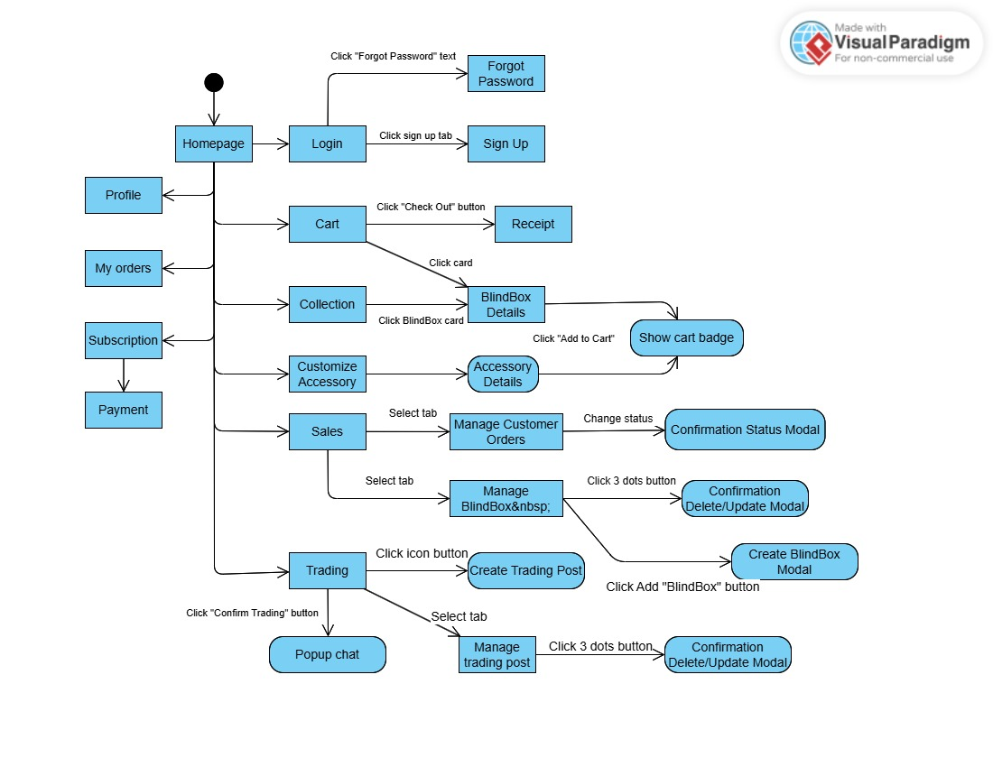

User ScreenFlow

| **Main Screens** | **Description** |
| --- | --- |
| Homepage | This is the entry point for users. Users can navigate to key sections. |
| Login Screen | Users enter credentials to access their accounts. Options available: Forgot Password (reset password) and Sign Up (register new account) |
| Cart Screen | Displays items added to the cart. Users can proceed to checkout to finalize purchases. |
| Receipt Screen | Displays transaction details after a successful checkout.. |
| Collection Screen | Shows available BlindBoxes. Users can click on a BlindBox card to view details. |
| Customize Accessory Screen | Allows users to customize blindbox accessories. Clicking an accessory navigates to Accessory Details. |
| Sales Screen | Manages sales with two sections: Manage Customer Orders (change order status with confirmation modal) and Manage BlindBox (CRUD BlindBoxes with confirmation modal). |
| Trading Screen | Users can engage in trading activities. Features include Create Trading Post (opens form to add BlindBoxes) and Manage Trading Post (modify listings with confirmation modal). User can make trading proposals. |
| Profile Screen | Displays user account details and settings. Users can edit personal information and update preferences. |
| My Orders Screen | Shows the user’s order history. Users can track order statuses, view order details and confirm successful orders. |
| Subscription Screen | Allows users to purchase credits. Users can view subscription plans, buy credits and check billing details. |

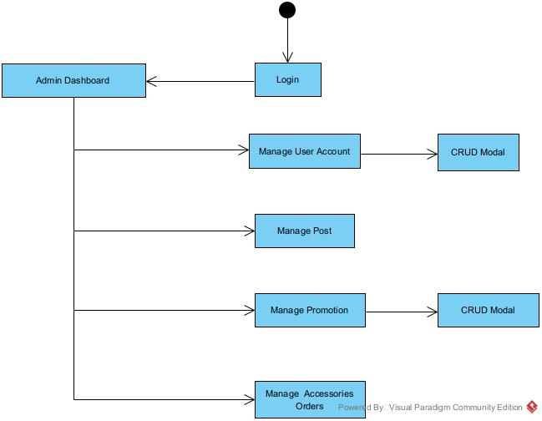

Admin ScreenFlow

| **Main Screens** | **Description** |
| --- | --- |
| Admin Dashboard | The central hub for administrators. Displays key metrics, including total users, posts, promotions, and accessory orders. Provides quick access to different management sections. |
| User Account Management | Allows admins to view, edit, and manage user accounts. Features include account activation/deactivation, role assignments, and user status updates. |
| Manage Posts | Enables admins to create, edit, and remove promotional campaigns. Admins can set discounts, expiration dates, and visibility settings. |
| Manage Accessories Orders | Admins oversee accessory purchases, track order statuses, and manage order fulfillment. Includes options to update shipping details. |

**Figma**

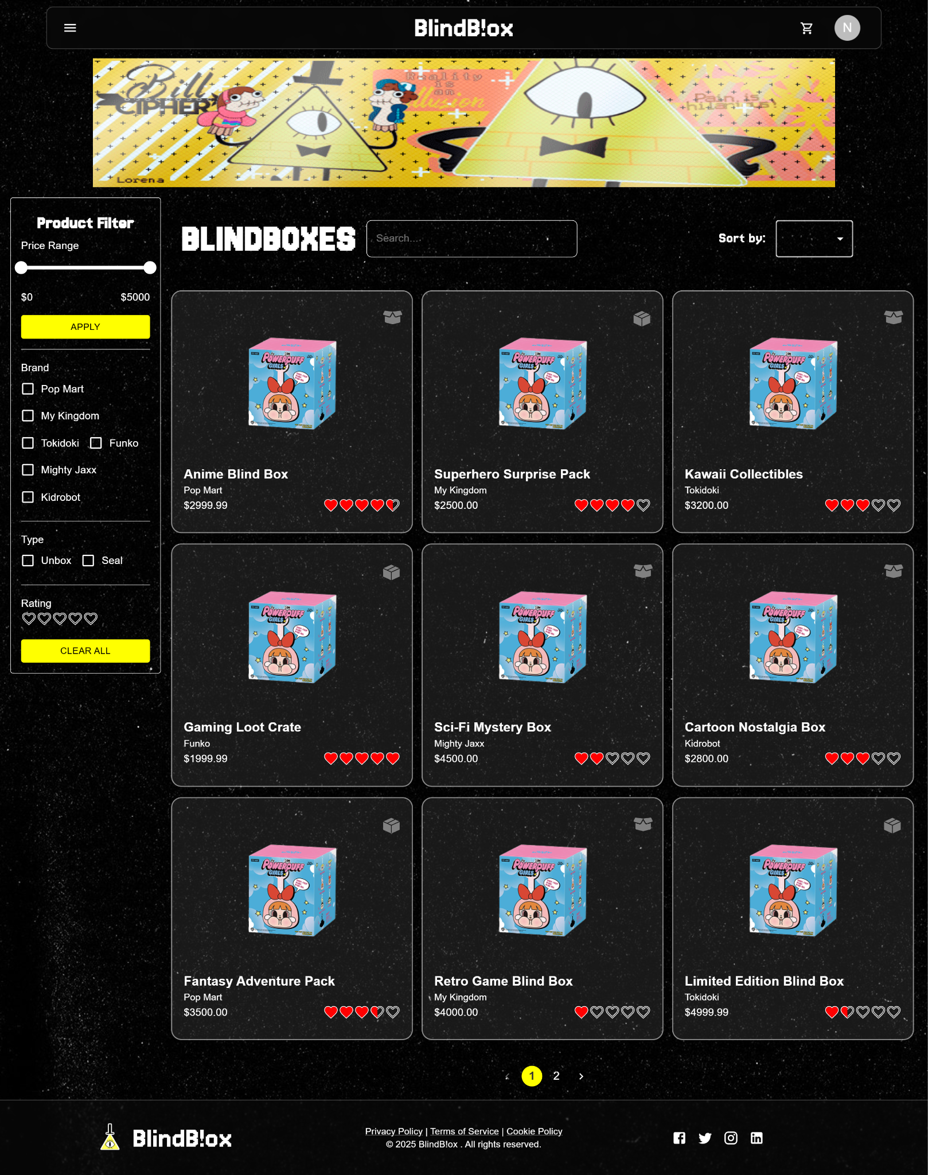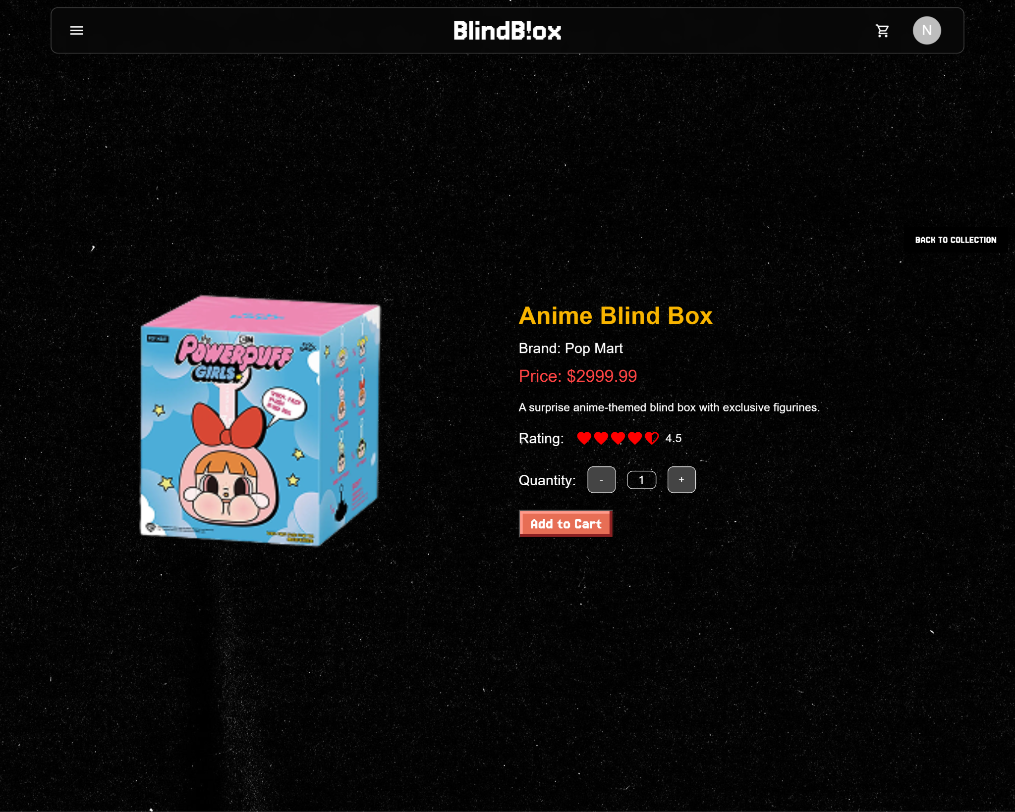

Collection Page and Detail Page

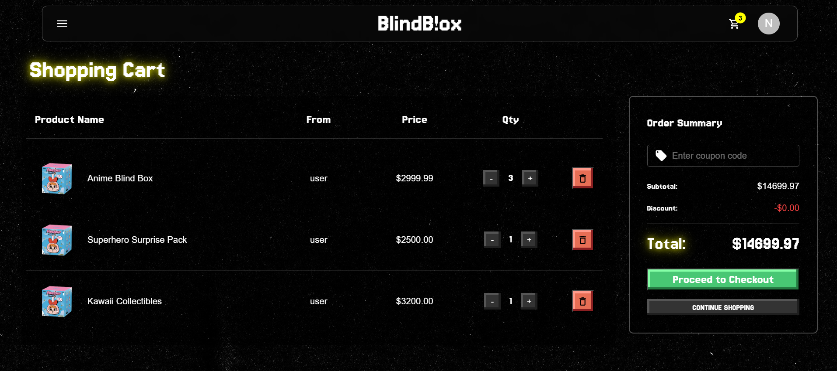

Cart Page

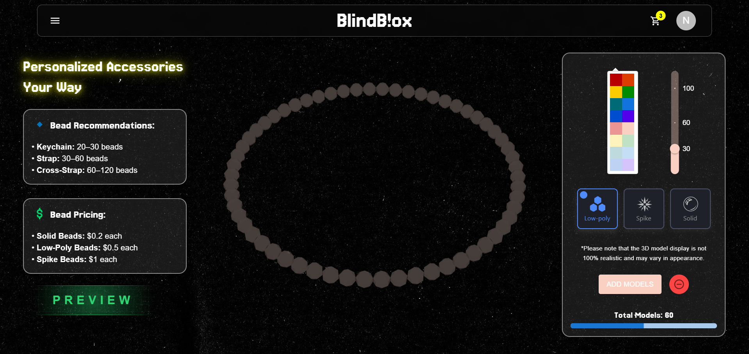

Customize Page

### 3.2 Buyer Functionalities (Duy)

### 3.2.1 Browse Accessories & Blind Box Products

* View available products with filters by category, price, and popularity.
* Search for specific blind box collectibles and accessories.

***3.2.2 View Product Details & Customize Accessories***

* View detailed product descriptions, images, and pricing.
* Customize available accessories before purchasing.

***3.2.3 Place Orders for Available Products***

* Add products to the cart and proceed to checkout.
* Specify delivery address and confirm the order.

***3.2.4 Secure Payments via Multiple Methods***

* Make payments using credit/debit cards, PayPal, or other supported methods.
* Receive instant payment confirmation.

***3.2.5 Apply Platform-Provided Promo Codes***

* Enter and apply discount codes before checkout.
* View the updated total price after discounts.

***3.2.6 Track Order Status & Delivery Updates***

* View real-time order processing and shipping updates.
* Receive notifications for order status changes.

***3.2.7 Leave Reviews***

* Rate and review purchased products.
* Provide feedback for sellers and traded items.

**3.3 Seller Functionalities**

**3.3.1 Create & Manage Selling Posts**

* List new blind box products and accessories for sale.
* Set pricing, product details, and availability status.

**3.3.2 Upload Product Details, Prices & Images**

* Provide high-quality product images and descriptions.
* Update product details as needed.

**3.3.3 Track & Update Available Stock**

* Manage inventory for listed products.
* Receive alerts when stock is low.

**3.3.4 View & Manage Incoming Orders**

* View and confirm incoming purchase requests.
* Process order packaging and shipping.

**3.3.5 Monitor Shipping & Processing Status**

* Update order status once shipped.
* Provide tracking information to buyers.

**3.3.6 Respond to Buyer Reviews & Feedback**

* View and reply to customer feedback.
* Address buyer concerns and inquiries.

**3.3.7 Analyze Sales Trends & Revenue via Dashboard**

* View sales statistics, revenue, and customer trends.
* Export reports for business insights.

**3.4 Trader Functionalities**

**3.4.1 Purchase Trade Credits for Exchanges**

* Buy trade credits to initiate exchanges on the platform.
* View transaction history for credits.

**3.4.2 Create Trade Posts for Unboxed Items**

* List unboxed collectibles for trade.
* Include images and descriptions.

**3.4.3 Get Trade Posts Approved by Admin**

* Submit trade listings for admin approval.
* Receive notifications upon approval or rejection.

**3.4.4 View & Search Available Trade Listings**

* Browse other users’ trade posts.
* Filter listings based on item type and value.

**3.4.5 Propose Trades to Other Users**

* Initiate trade proposals with other traders.
* Offer single or multiple items in a trade.

**3.4.6 Review & Accept Trade Offers**

* View trade proposals from other users.
* Accept, reject, or counter trade offers.

**3.4.7 Add Multiple Items or Cash to Balance Trades**

* Adjust trade offers by adding additional items or cash.
* Finalize trades upon mutual agreement.

**3.5 Admin Functionalities**

**3.5.1 Manage User Accounts**

* Approve or deactivate user accounts.
* Monitor user activity and resolve disputes.

**3.5.2 Moderate User Posts, Reviews & Messages**

* Review selling and trade posts before approval.
* Monitor and remove inappropriate reviews or messages.

**3.5.3 Approve & Reject Trade & Selling Posts**

* Ensure all listings comply with platform guidelines.
* Accept or reject submissions based on quality and authenticity.

**3.5.4 Enforce Platform Policies & Community Guidelines**

* Set and maintain platform rules.
* Issue warnings or bans for violations.

**3.5.5 Monitor System KPIs & Financial Performance**

* Track key metrics such as transactions, user engagement, and sales volume.
* Generate financial performance reports.

**3.5.6 Handle Flagged Issues & Disputes**

* Review and resolve reported disputes between users.
* Take necessary actions based on investigation results.

## 4. Non-Functional Requirements (Duy)

### 4.1 External Interfaces

The BlindB!ox will interact with users and externals systems to ensure a smooth experience for users:

* **User Interface (UI)**: A web-based interface using React and Tailwind CSS to be accessible via desktop, mobile browsers and apps, designed for easy navigation.
* **External Service:**
* SePay Payment Service - solution for open banking
* Redis Cache Storage - In-memory data structure store used for caching
* Aws S3 - Object data storage
* Aws Ses - cloud-based email sending service
* **Authentication and Security**: OAuth & Social Login integration (Google) for user convenience. Data encryption for sensitive information storage and transmission.

### 4.2 Quality Attributes

1. **Usage**

* User-friendly interface with intuitive navigation and clean design.
* Mobile responsiveness to support various screen sizes and devices.

1. **Performance & Scalability**

* System should handle high concurrent user traffic without performance degradation.
* Response time for common actions should be under 2 seconds.
* The database should support efficient indexing and caching to optimize queries.

1. **Maintainability**

* Modular architecture to facilitate easy updates and feature enhancements.
* Well-documented APIs and codebase for future development and integrations.

1. **Security**

* Role-based access control (RBAC) to restrict user permissions.
* End-to-end encryption (SSL/TLS) for secure data transmission.

## 5. Requirement Appendix

1. **UML Diagram**

A visual representation of the system's structure and behavior, including class diagrams, use case diagrams, and sequence diagrams to illustrate system interactions and relationships.

1. **NodeJs**

The backend of the system will be built using Node.js, leveraging its asynchronous, event-driven architecture to handle multiple concurrent requests efficiently.

1. **React**

The frontend will be developed using React, providing a dynamic and responsive user experience.

1. **MongoDB**

The system will use MongoDB as the primary database due to its flexibility in handling unstructured data, scalability, and ease of integration with Node.js.

1. **SePay**

The platform will integrate with SePay, a payment processing service, to facilitate secure transactions.

1. **AWS**

The system will be deployed on AWS (Amazon Web Services) to ensure scalability, reliability, and security.

**Business Rule**

# IV. Software Design Description

## 1. System Design

### 1.1 System Architecture (Phước)

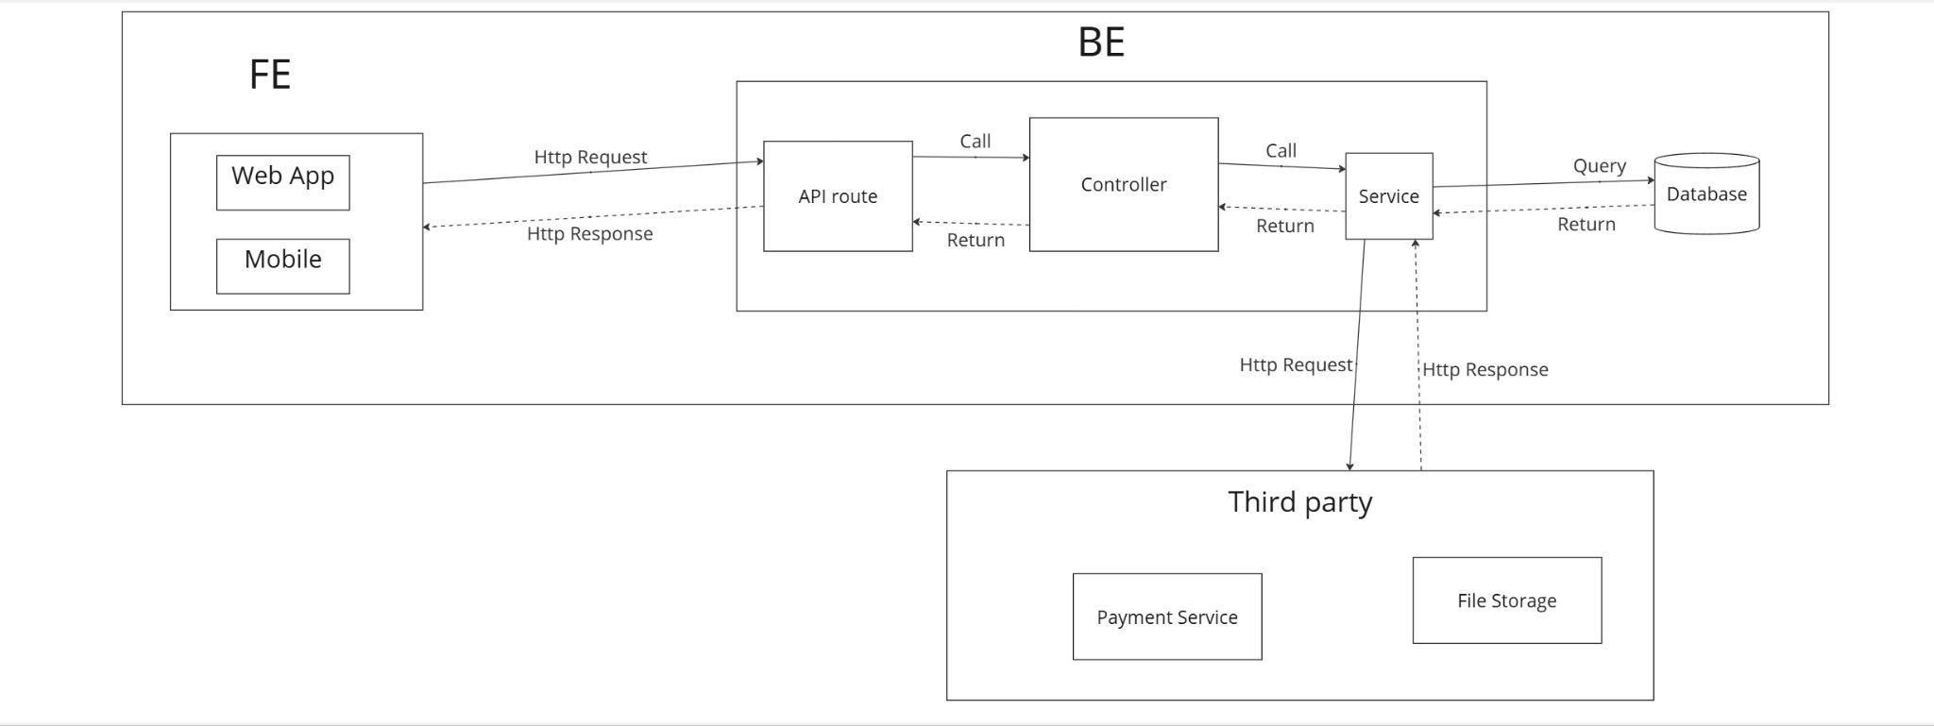

**Overall Architecture**

The diagram depicts a web application architecture between:

* BE (Backend): Built with NodeJs
* FE (Frontend): Consisting of React Web App and Android Mobile applications

## Backend Components (NodeJs)

1. **Controller**

* Serves as the entry point for API requests
* Communicates with Security & Auth, Service layer
* Handles routing and request processing

1. **API route**

* Manages authentication and authorization
* Interacts with the Controller for securing API endpoints

1. **Service**

* Contains business logic
* Communicates with Repository layer and external clients
* Orchestrates operations between different system components

## Frontend Components

1. **Web App**

* Built with ReactJS
* Communicates with backend through the API

1. **Mobile**

* Android application
* Also communicates with the backend through the API

### 1.2 Package Diagram (Giang, Khôi, Phước)

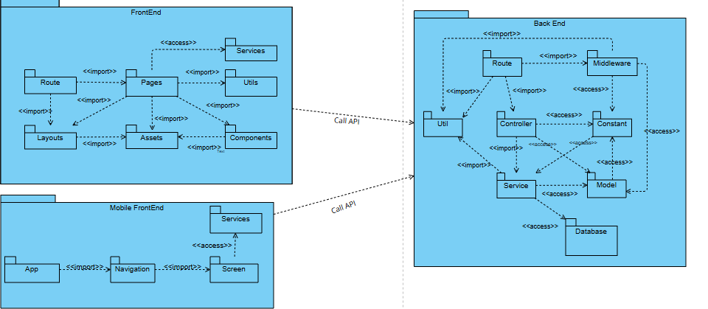

| Package | Description |
| --- | --- |
| Front End | The main frontend package that manages the UI, user interactions, and API communication. |
| Pages | The package contains different views of the application, representing individual screens or pages. |
| Layouts | The package provides reusable layout structures for different pages to maintain consistency. |
| Assets | The package contains static resources such as images, fonts, and styles. |
| Components | The package includes reusable UI elements, such as buttons, cards, and modals. |
| Services | The package that handles API calls and business logic related to data fetching and manipulation. |
| Utils | The package provides utility functions for common operations like formatting, validation, and data processing. |
| Back End | The package which provides API to interact with Web Application |
| Route | The package define API endpoints and connect them to their corresponding controllers/middlewares |
| Middleware | The package handles the logic between requests and controllers |
| Controller | The package handle business logic and interact with services |
| Service | The package contain core business logic and interact with the database |
| Model | The package define data structures |
| Constant | The package provide consistent values across the application |
| Util | The package provide helper functionality |
| Third party | The package include external services |
| Aws Sdk | The package provide functionality to interact with AWS services |
| Database | The package provide database connection and configuration |
| Mobile FrontEnd | The mobile frontend package is responsible for the user interface and interactions on mobile devices, ensuring a seamless experience across different screen sizes and platforms. |
| App | The core entry point of the mobile application, initializing the navigation. |
| Navigation | This package manages the navigation structure, including stack navigation, tab navigation, and screen transitions |
| Screen | Contains different screens of the mobile application, representing specific functionalities or user interactions. |
| Services | The package contain core business logic and interact with the database |

### 1.3 Activity Diagram (Giang, Khôi, Anh)

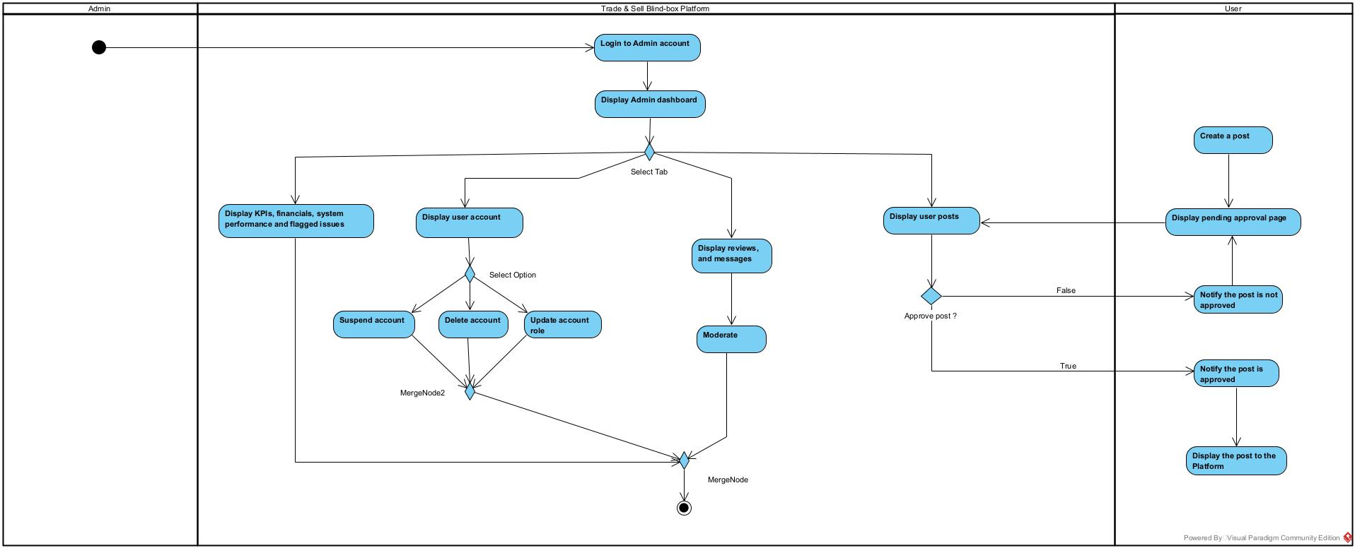

Admin

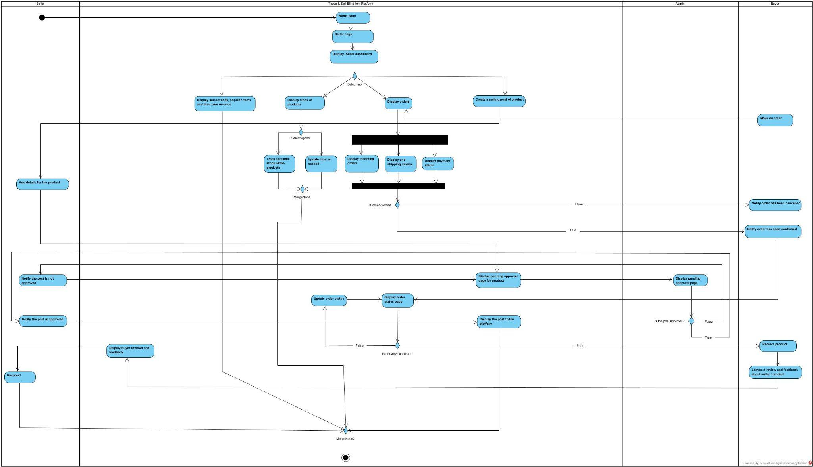

Seller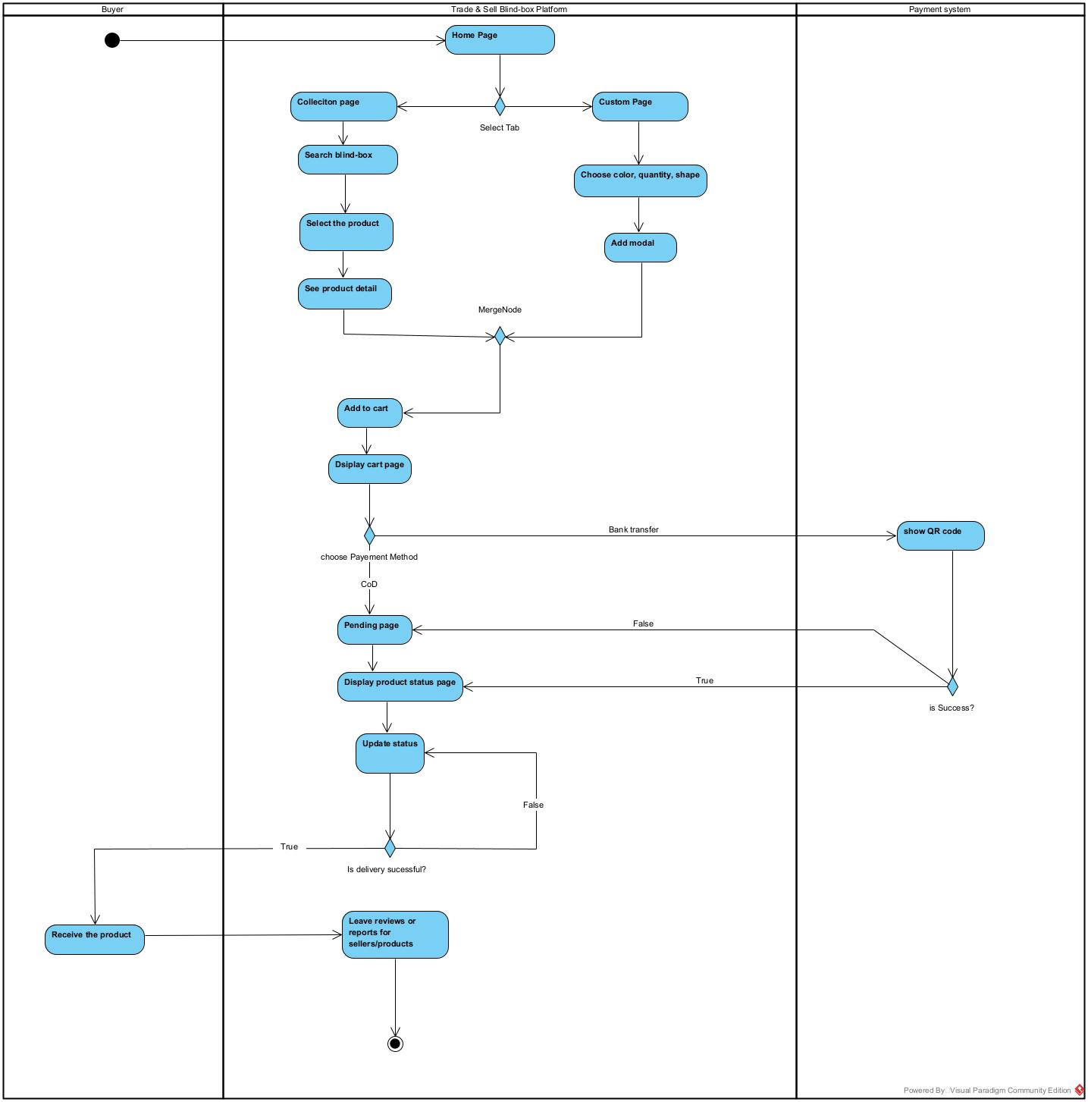

Buyer

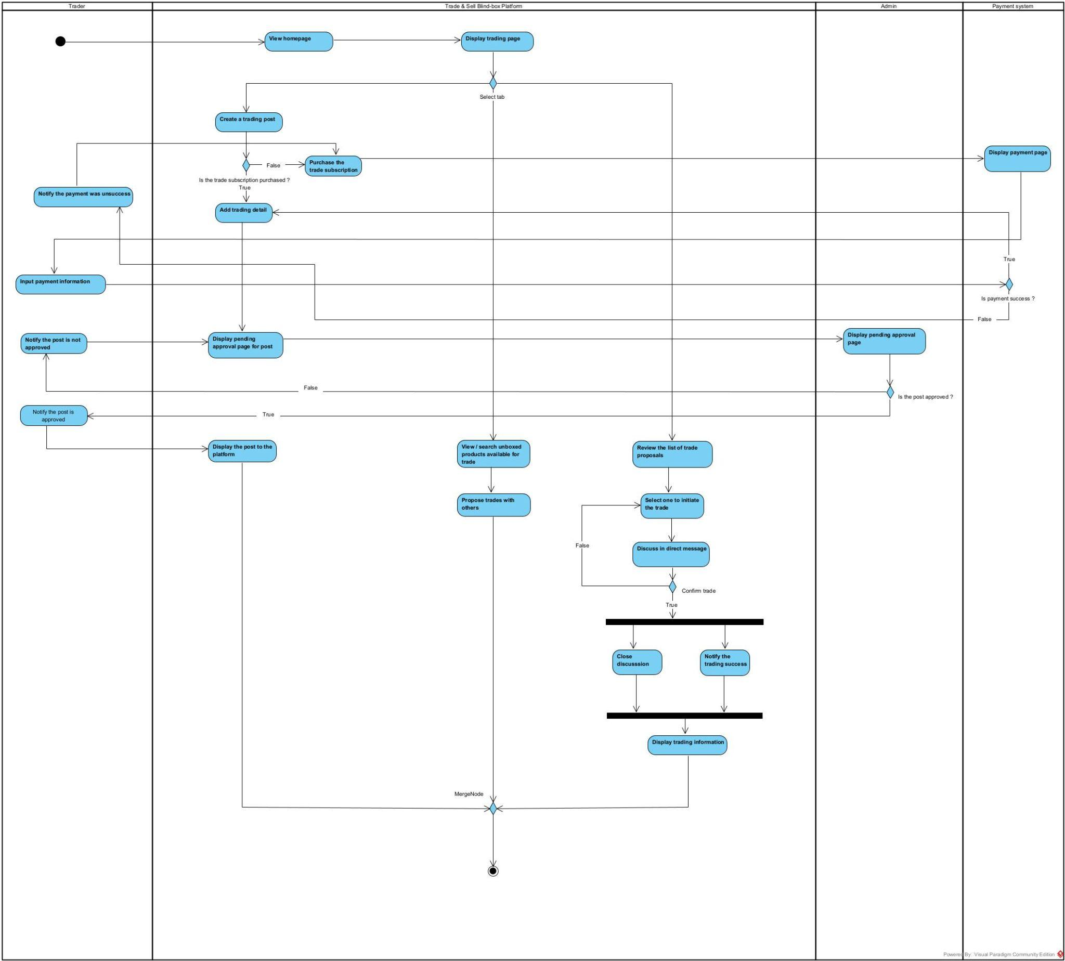

## 

Trader

## 2. Database Design (All Members)

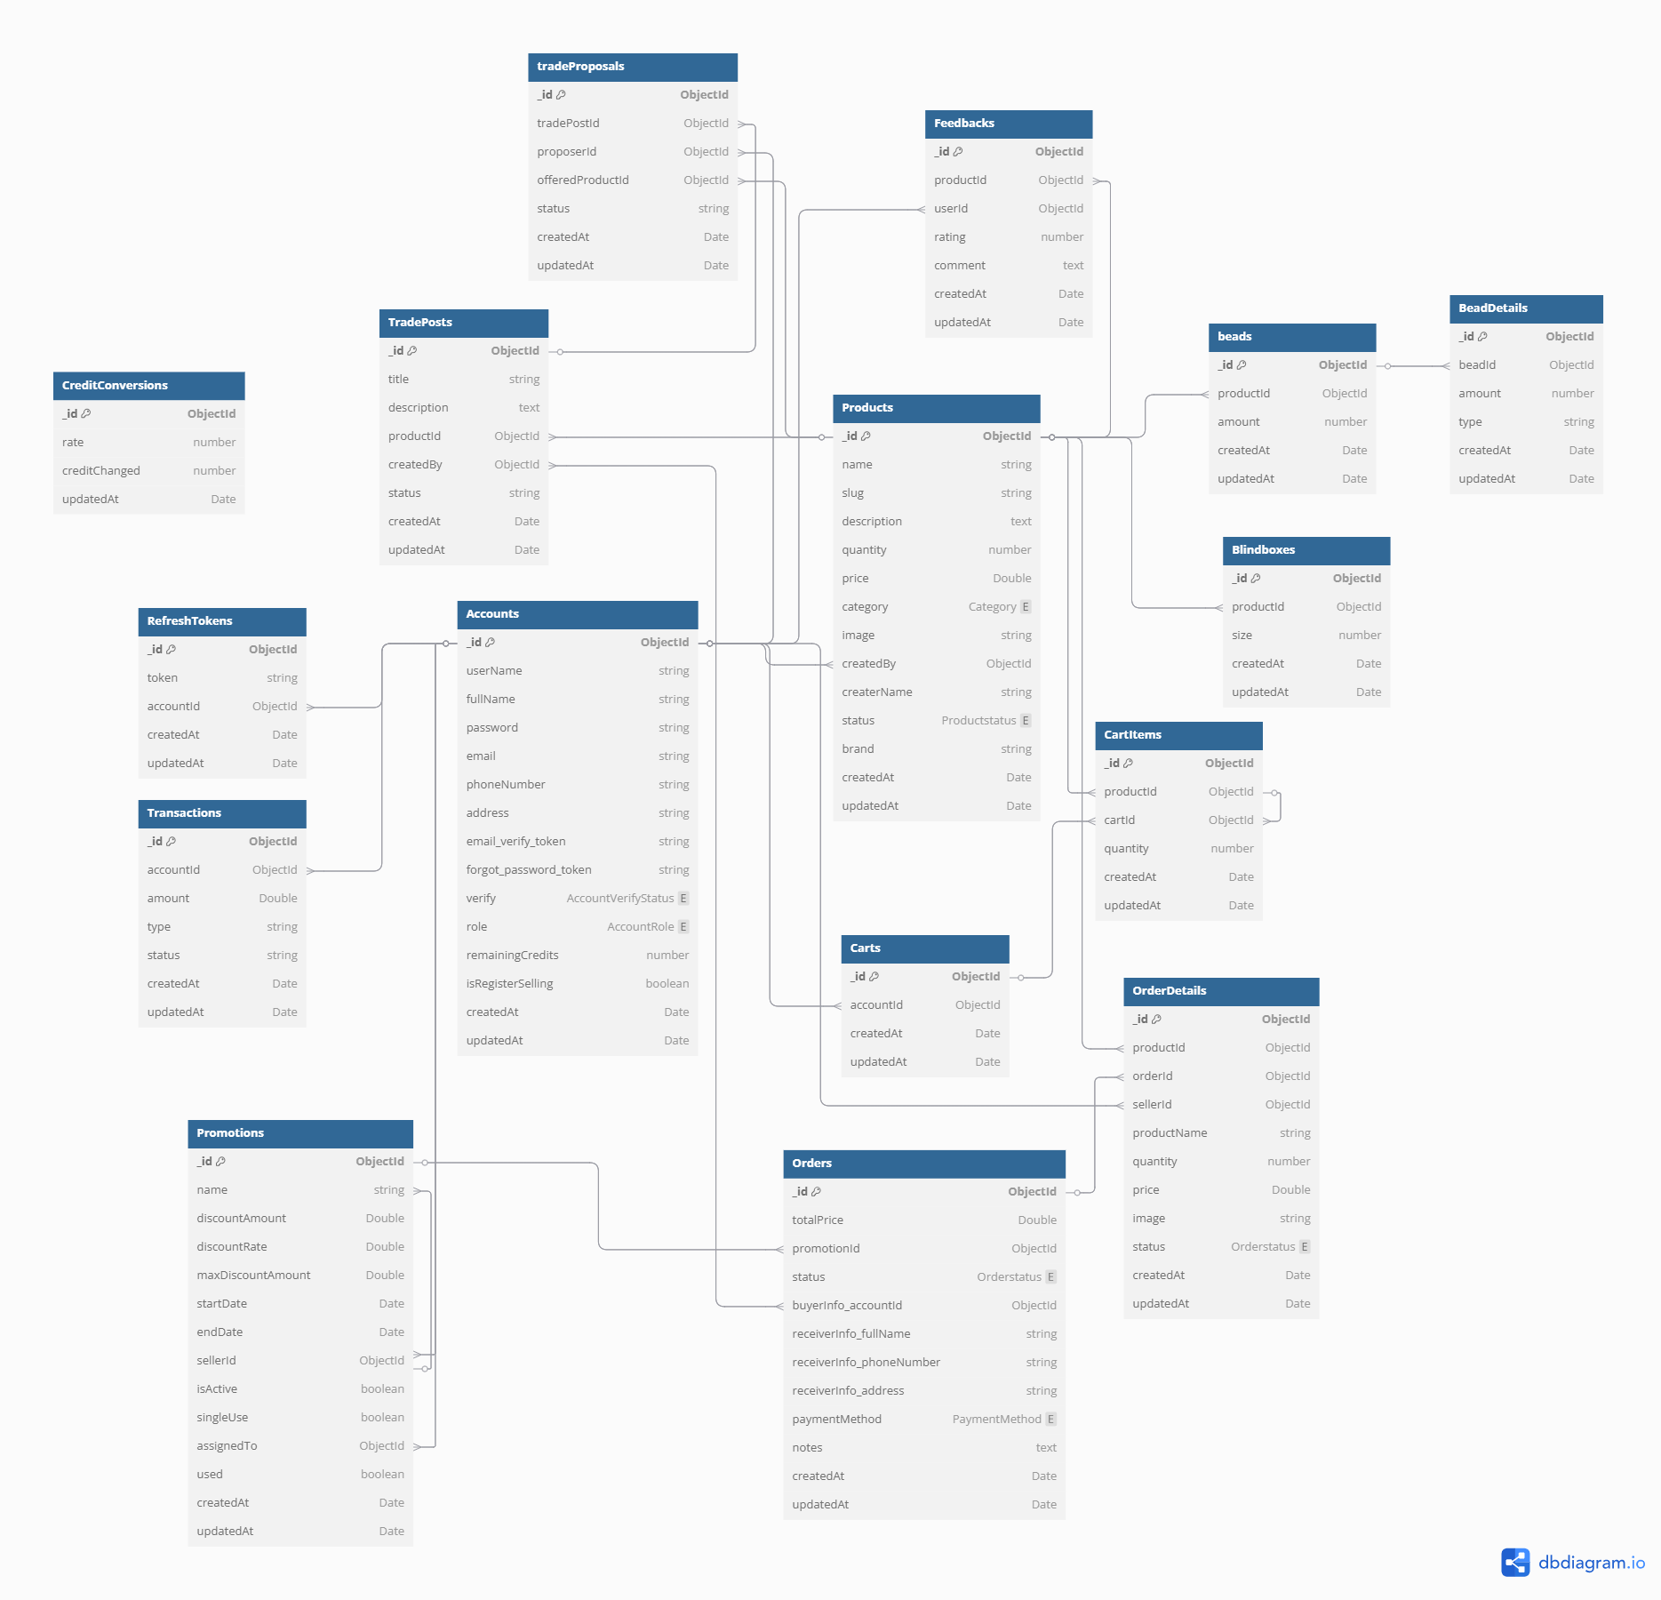

**2.1 Database Table Relationship (Duy)**

**2.1.1 Account**

* Related to Transaction, Cart, Order, Feedback, through the accountId field
* Related to Product through the createdBy field
* Related to Promotion through the sellerId field
* Related to TradePost through the authorId field
* Related to TradeProposal through the proposer field

**2.1.2 Product**

* Related to Accounts through the createBy field

**2.1.3 Cart**

* Related to Accounts through the accountId field
* Related to CartItems through the cartId field

**2.1.4 CartItems**

* Related to Cart through the cartId field
* Related to Products through the productId field

**2.1.5 Orders**

* Related to Accounts through the accountId field
* Related to TradePost through the tradePostId field
* Related to Promotions through the promotionId field

**2.1.6 TradePosts**

* Related to Accounts through the authorId field
* Related to TradeProposals through the tradePostId field

**2.1.7 TradeProposals**

* Related to TradePosts through the postId field
* Related to Accounts through the proposer field

**2.1.8 Feedbacks**

* Related to Accounts through the accountId field
* Related to Products through the productId field

**2.1.9 Transactions**

* Related to Accounts through the accountId field

**2.1.10 Promotions**

* Related to Accounts through the sellerId field

**2.1.11 OrderDetails**

* Related to Orders through the orderId field

**2.1.12 Refresh Tokens**

* Related to Accounts through the account_id field

**2.1.13 CreditConversion**

* Independent table for credit rate management

**2.1.14 Products**

* Related to Accounts through the createdBy field
* Related to OpenItems through the openItems field
* Related to BlindBoxes through the blindBoxes field
* Related to Accessories through the accessories field

**2.1.15 OpenItems**

* Related to Products through the productId field

**2.1.16 BlindBoxes**

* Related to Products through the productId field

**2.1.17 Accessories**

* Related to Products through the productId field
* Related to Components through the components field

**2.1.18 Components**

* Related to Accessories through the accessoriesId field

**2.2 Table Description (Duy)**

**Accounts**

| **Field Name** | **Type** | **Size** | **Unique** | **Nullable** | **PK/FK** | **Description** |
| --- | --- | --- | --- | --- | --- | --- |
| _id | ObjectId | _ | Yes | No | PK | Unique value to identify account’s information |
| userName | String | 50 | Yes | No | _ | Unique username for the account |
| fullName | String | 100 | No | No | _ | Full name of the account holder |
| password | String | No | No | No | _ | Encrypted password for authentication |
| email | String | 100 | Yes | No | _ | Email address associated with the account |
| phoneNumber | String | 20 | No | Yes | _ | Contact phone number |
| address | String | 255 | No | Yes | _ | Residential or business address |
| email_verify_token | String | 255 | Yes | Yes | _ | Token for email verification |
| forgot_password_token | String | 255 | No | Yes | _ | Token for password reset functionality |
| remainingCredits | Number | _ | No | No | _ | Available credits for creating trade |
| isRegisterSelling | Boolean | _ | No | No | _ | Whether the user is registered as a seller |

**Products**

| **Field Name** | **Type** | **Size** | **Unique** | **Nullable** | **PK/FK** | **Description** |
| --- | --- | --- | --- | --- | --- | --- |
| _id | ObjectId | _ | Yes | No | PK | Unique identifier for the product |
| name | String | 255 | No | No | _ | Product name |
| description | String | 1000 | No | Yes | _ | Product description |
| quantity | Number | _ | No | No | _ | Available quantity in stock |
| price | Number | _ | No | No | _ | Price of the product |
| category | String | 255 | No | No | _ | Category of the product |
| image | String | 500 | No | No | _ | Image URL of the product |
| createBy | ObjectId | _ | No | No | FK | Reference to the seller's account |
| status | ProductStatus | 255 | No | No | _ | Status of the product |
| brand | String | 255 | No | Yes | _ | Brand associated with the product |

**Orders**

| **Field Name** | **Type** | **Size** | **Unique** | **Nullable** | **PK/FK** | **Description** |
| --- | --- | --- | --- | --- | --- | --- |
| _id | ObjectId | _ | Yes | No | PK | Unique identifier for the order |
| accountId | ObjectId | _ | No | No | FK | Reference to the account placing the order |
| totalPrice | String | _ | No | No | _ | Total price of the order |
| promotionId | Number | _ | No | Yes | FK | Reference to any applied promotion |
| status | Number | 50 | No | No | _ | Status of the order |

**Orders Detail**

| **Field Name** | **Type** | **Size** | **Unique** | **Nullable** | **PK/FK** | **Description** |
| --- | --- | --- | --- | --- | --- | --- |
| _id | ObjectId | _ | Yes | No | PK | Unique identifier for the order detail entry |
| productName | string | 255 | No | No | _ | Name of the purchased product |
| quantity | number | _ | No | No | FK | Quantity of the product in the order |
| price | number | _ | No | No | _ | Price of the product at the time of order |
| image | string | 500 | No | Yes | FK | Image URL of the product |
| orderId | ObjectId | _ | No | No | _ | Reference to the corresponding order |

**Promotion**

| **Field Name** | **Type** | **Size** | **Unique** | **Nullable** | **PK/FK** | **Description** |
| --- | --- | --- | --- | --- | --- | --- |
| _id | ObjectId | _ | Yes | No | PK | Unique identifier for the promotion |
| name | string | 255 | No | No | _ | Name of the promotion |
| discountRate | number | _ | No | No | _ | Discount rate applied to products |
| startDate | Date | _ | No | No | _ | Start date of the promotion |
| endDate | Date | _ | No | No | _ | End date of the promotion |
| sellerId | ObjectId | _ | No | No | FK | Reference to the seller who created the promotion |
| isActive | boolean | _ | No | No | _ | Indicates whether the promotion is currently active |

**Cart**

| **Field Name** | **Type** | **Size** | **Unique** | **Nullable** | **PK/FK** | **Description** |
| --- | --- | --- | --- | --- | --- | --- |
| _id | ObjectId | _ | Yes | No | PK | Unique identifier for the cart |
| accountId | ObjectId | _ | No | No | FK | Reference to the account that owns the cart |
| createdAt | Date | _ | No | No | _ | Timestamp when the cart was created |

**Cart Items**

| **Field Name** | **Type** | **Size** | **Unique** | **Nullable** | **PK/FK** | **Description** |
| --- | --- | --- | --- | --- | --- | --- |
| _id | ObjectId | _ | Yes | No | PK | Unique identifier for the cart item |
| productId | ObjectId | _ | No | No | FK | Reference to the product in the cart |
| quantity | number | _ | No | No | _ | Number of items added to the cart |
| cartId | ObjectId | _ | No | No | FK | Reference to the associated cart |
| createdAt | Date | _ | No | No | _ | Timestamp when the item was added to the cart |

**BlindBoxes**

| **Field Name** | **Type** | **Size** | **Unique** | **Nullable** | **PK/FK** | **Description** |
| --- | --- | --- | --- | --- | --- | --- |
| _id | ObjectId | _ | Yes | No | PK | Unique identifier for the cart item |
| productId | ObjectId | _ | No | No | FK | Reference to the product in the cart |
| quantity | number | _ | No | No | _ | Number of items added to the cart |
| cartId | ObjectId | _ | No | No | FK | Reference to the associated cart |
| createdAt | Date | _ | No | No | _ | Timestamp when the item was added to the cart |

**Accessories**

| **Field Name** | **Type** | **Size** | **Unique** | **Nullable** | **PK/FK** | **Description** |
| --- | --- | --- | --- | --- | --- | --- |
| totalPrice | double | _ | No | No | _ | The total price of the accessory. |
| totalBeads | int | _ | No | No | _ | The total number of beads in the accessory. |
| type | number | _ | No | No | _ | The type/category of the accessory. |
| components | ObjectId | _ | No | No | _ | A list of component objects for the accessory. |

**Components**

| **Field Name** | **Type** | **Size** | **Unique** | **Nullable** | **PK/FK** | **Description** |
| --- | --- | --- | --- | --- | --- | --- |
| color | string | _ | No | No | _ | The color of the component. |
| shape | string | _ | No | No | _ | The shape of the component. |
| type | string | _ | No | No | _ | The price of the component. |
| price | number | _ | No | No | _ | The position of the component in the list. |

## 3. Detailed Design (All Members)

#### 3.1.1 Class Diagram

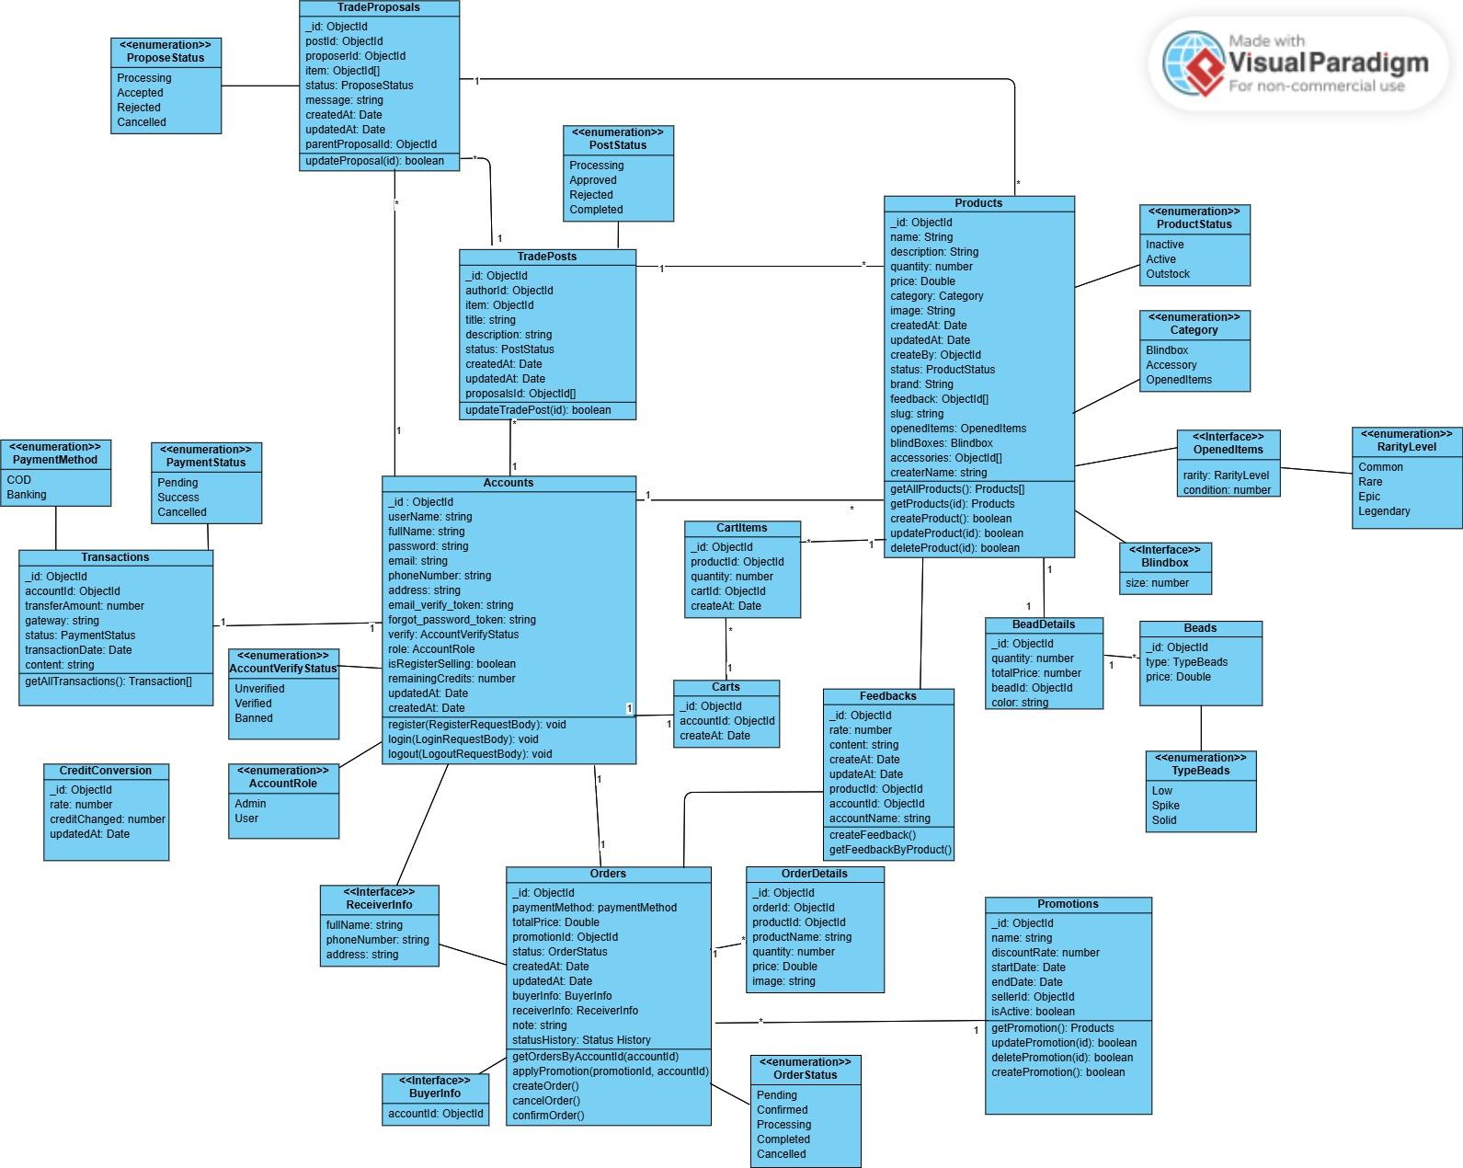

| **No** | **Entity** | **Description** |
| --- | --- | --- |
| 1 | Accounts | The account of user and admin in system |
| 2 | Products | The products of blind boxes, accessories |
| 3 | Feedbacks | The feedback and reviews on products |
| 4 | BlindBoxes | The mystery boxes containing random items |
| 5 | OpenedItems | The unboxed items |
| 6 | Accessories | The additional items as part of a blind box |
| 7 | Components | The individual part include inside accessories |
| 8 | Carts | The temporary storage for users' selected items before making a purchase |
| 9 | CartItems | The items added to a cart, linking specific products to a user’s cart |
| 10 | Orders | The records completed purchases |
| 11 | OrderDetails | The detailed breakdown of items in an order |
| 12 | Promotions | Discount campaigns, vouchers, and special offers available to users |
| 13 | TradePosts | Listings created by users to propose trades of products with other users |
| 14 | TradeProposals | Counteroffers or trade requests submitted in response to trade posts |
| 15 | Transactions | Records of all financial activities, including purchases, deposits |
| 16 | CreditConversion | The exchange rate between VND and credits |

#### 

#### 3.1.1.1 Class Specification

**Accounts**

| **Field Name** | **Type** | **Description** |
| --- | --- | --- |
| _id | ObjectId | Unique value to identify account’s information |
| userName | string | Unique username for the account |
| fullName | string | Full name of the account holder |
| password | string | Encrypted password for authentication |
| email | string | Email address associated with the account |
| phoneNumber | string | Contact phone number |
| address | string | Residential or business address |
| email_verify_token | string | Token for email verification |
| forgot_password_token | string | Token for password reset functionality |
| remainingCredits | number | Available credits for creating trade |
| isRegisterSelling | boolean | Whether the user is registered as a seller |

| **Method** | **Return Type** | **Description** |
| --- | --- | --- |
| register | void | create a new user in BlindB!ox system |
| login | void | user login BlindB!ox system |
| logout | void | Logs out the user and terminates session. |

**Products**

| **Field Name** | **Type** | **Description** |
| --- | --- | --- |
| _id | ObjectId | Unique identifier for the product |
| name | string | Product name |
| description | string | Product description |
| quantity | number | Available quantity in stock |
| price | string | Price of the product |
| category | Category | Category of the product |
| image | string | Image URL of the product |
| createBy | ObjectId | Reference to the seller's account |
| status | ProductStatus | Status of the product |

| **Method** | **Return Type** | **Description** |
| --- | --- | --- |
| getAllProduct() | Products[] | Retrieves all products. |
| getProduct(id: ObjectId) | Products | Retrieves a product by its ID. |
| createProduct(product: object) | boolean | Creates a new product. |
| updateProduct(id: ObjectId, data: object) | boolean | Updates an existing product. |
| deleteProduct(id: ObjectId) | boolean | Deletes a product. |

**Orders**

| **Field Name** | **Type** | **Description** |
| --- | --- | --- |
| _id | ObjectId | Unique identifier for the order |
| accountId | ObjectId | Reference to the account placing the order |
| totalPrice | number | Total price of the order |
| promotionId | ObjectId | Reference to any applied promotion |
| status | OrderStatus | Status of the order |

| **Method** | **Return Type** | **Description** |
| --- | --- | --- |
| getAllOrders() | Orders[] | Retrieves all orders. |
| getOrder(id: ObjectId) | Orders | Retrieves an order by its ID. |
| createOrder(order: object) | boolean | Creates a new order. |
| updateOrder(id: ObjectId, data: object) | boolean | Updates an existing order. |
| deleteOrder(id: ObjectId) | boolean | Deletes an order. |

**Orders Detail**

| **Field Name** | **Type** | **Description** |
| --- | --- | --- |
| _id | ObjectId | Unique identifier for the order detail entry |
| productName | string | Name of the purchased product |
| quantity | number | Quantity of the product in the order |
| price | number | Price of the product at the time of order |
| image | string | Image URL of the product |
| orderId | ObjectId | Reference to the corresponding order |

| **Method** | **Return Type** | **Description** |
| --- | --- | --- |
| getAllOrderDetails() | OrderDetails[] | Retrieves all order details. |
| getOrderDetail(id: ObjectId) | OrdersDetail | Retrieves order details by ID. |

**Promotions**

| **Field Name** | **Type** | **Description** |
| --- | --- | --- |
| _id | ObjectId | Unique identifier for the promotion |
| name | string | Name of the promotion |
| discountRate | number | Discount rate applied to products |
| startDate | Date | Start date of the promotion |
| endDate | Date | End date of the promotion |
| sellerId | ObjectId | Reference to the seller who created the promotion |
| isActive | boolean | Indicates whether the promotion is currently active |

| **Method** | **Return Type** | **Description** |
| --- | --- | --- |
| getAllPromotions() | Promotions[] | Retrieves all promotions. |
| createPromotion(promotion: object) | Promotions | Creates a new promotion. |
| updatePromotion(id: ObjectId, data: object) | boolean | Updates an existing promotion. |
| deletePromotion(id: ObjectId) | boolean | Deletes a promotion. |
| getActivePromotions() | Promotions[] | Retrieves all active promotions. |

**Carts**

| **Field Name** | **Type** | **Description** |
| --- | --- | --- |
| _id | ObjectId | Unique identifier for the cart |
| accountId | ObjectId | Reference to the account that owns the cart |
| createdAt | Date | Timestamp when the cart was created |

**Carts Items**

| **Field Name** | **Type** | **Description** |
| --- | --- | --- |
| _id | ObjectId | Unique identifier for the cart item |
| productId | ObjectId | Reference to the product in the cart |
| quantity | number | Number of items added to the cart |
| cartId | ObjectId | Reference to the associated cart |
| createdAt | Date | Timestamp when the item was added to the cart |

**BlindBoxes**

| **Field Name** | **Type** | **Description** |
| --- | --- | --- |
| productId | ObjectId | Unique identifier for the blind box product |
| size | number | Size of the blind box |
| createdAt | Date | Timestamp when the blind box was created |

**Accessories**

| **Field Name** | **Type** | **Description** |
| --- | --- | --- |
| productId | ObjectId | Unique identifier for the accessory |
| totalPrice | Double | Total price of the accessory |
| totalBeads | number | Number of beads in the accessory |
| type | string | Type or category of the accessory |

**Components**

| **Field Name** | **Type** | **Description** |
| --- | --- | --- |
| accessoryId | ObjectId | Reference to the related accessory |
| color | string | Color of the component |
| shape | string | Shape of the component |
| price | Double | Price of the individual component |
| orderIndex | number | Position/order of the component in the accessory |

**Feedback**

| **Field Name** | **Type** | **Description** |
| --- | --- | --- |
| _id | ObjectId | Unique identifier for the feedback |
| rate | number | Rating given by the user (e.g., 1-5 stars) |
| content | string | User's review or feedback content |
| productId | ObjectId | Reference to the product being reviewed |

**Tradepost**

| **Field Name** | **Type** | **Description** |
| --- | --- | --- |
| _id | ObjectId | Unique identifier for the trade post |
| authorId | ObjectId | Reference to the user who created the post |
| item | ObjectId | Reference to the item being traded |
| title | string | Title of the trade post |
| description | string | Detailed description of the trade post |
| status | PostStatus | Status of the trade post (e.g., active, closed) |
| proposalsId | ObjectId | List of proposal IDs linked to this trade post |

**TradeProposal**

| **Field Name** | **Type** | **Description** |
| --- | --- | --- |
| _id | ObjectId | Unique identifier for the trade proposal |
| postId | ObjectId | Reference to the trade post |
| proposerId | ObjectId | Reference to the user making the proposal |
| item | string | Reference to the item being offered in the proposal |
| status | ProposeStatus | Status of the trade proposal (e.g., pending, accepted, rejected) |
| message | string | Message from the proposer |

**Transactions**

| **Field Name** | **Type** | **Description** |
| --- | --- | --- |
| _id | ObjectId | Unique identifier for the transaction |
| accountId | ObjectId | Reference to the user account |
| amount | number | Transaction amount |
| method | PaymentMethod | Payment method used |
| status | PaymentStatus | Status of the transaction (e.g., pending, completed, failed) |
| transactionDate | Date | Date and time of the transaction |
| createdAt | Date | Timestamp when the transaction was created |

***3.1.2 Sequence Diagram Login (Phước)***

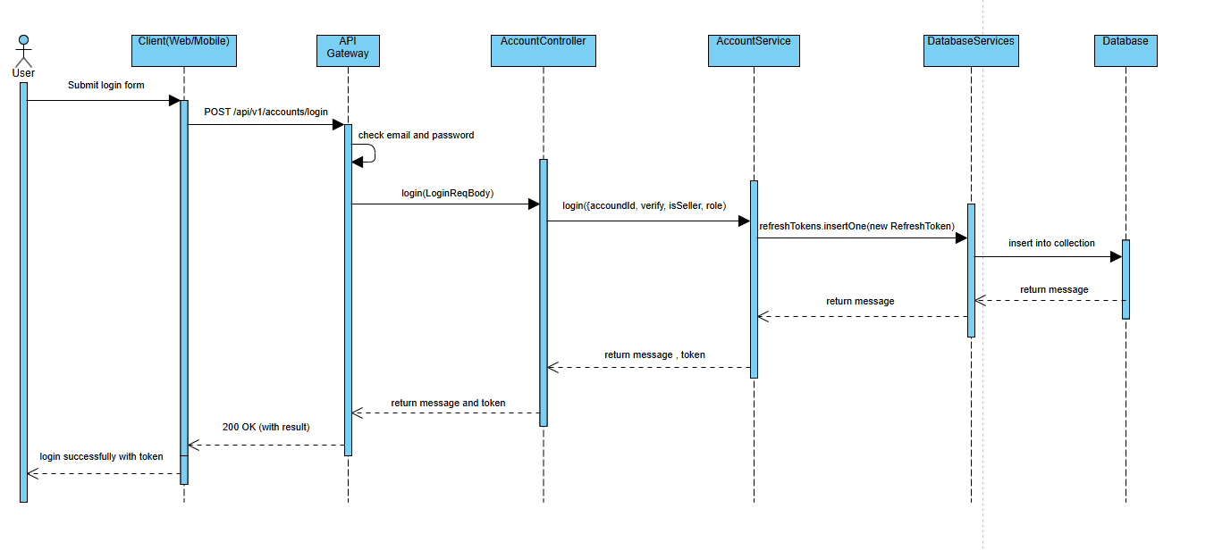

***3.1.2 Sequence Diagram Register***

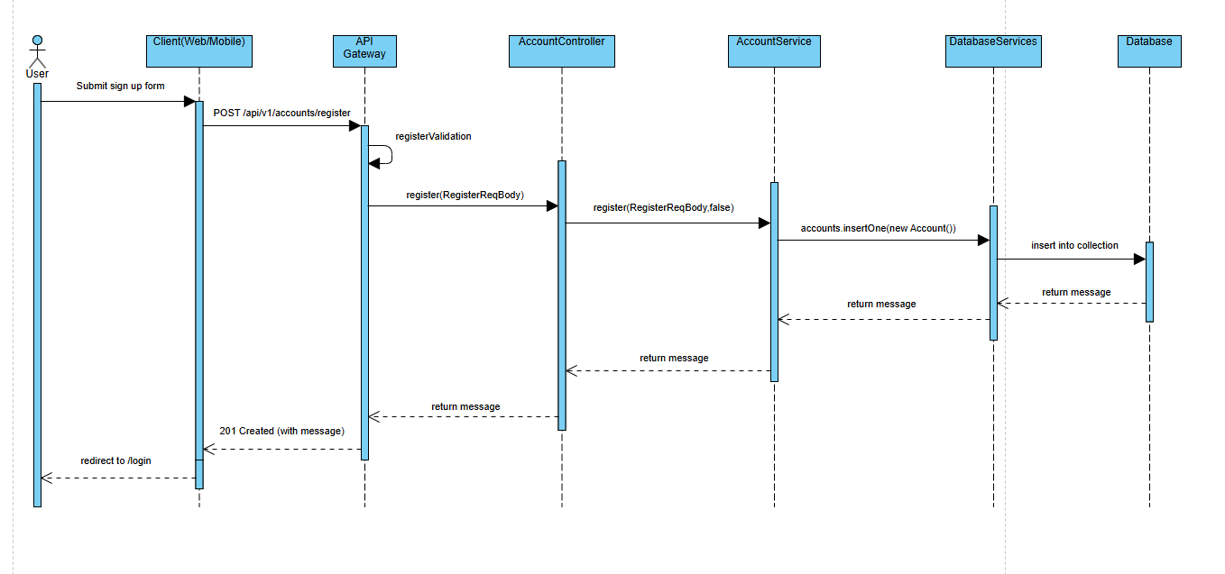

***3.1.2 Sequence Diagram Get List Blind Boxes***

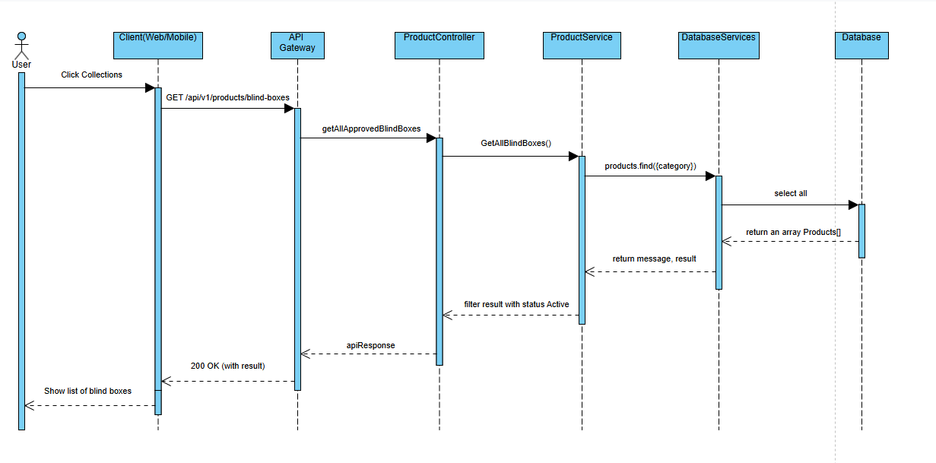

***3.1.2 Sequence Diagram Add to Cart***

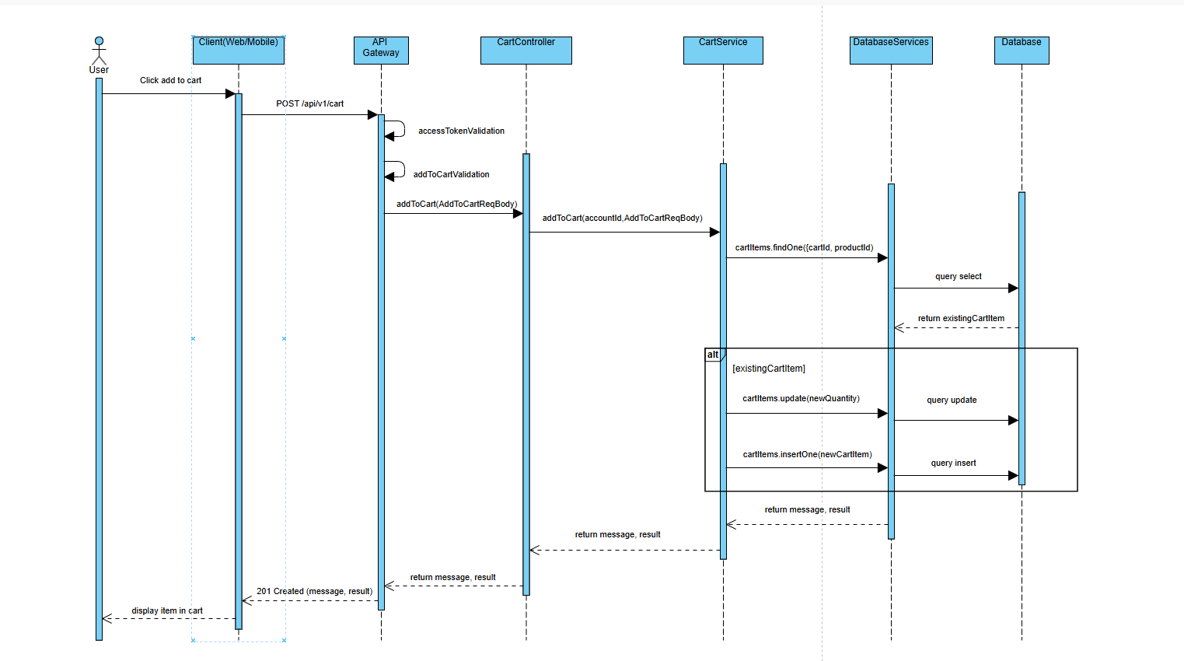

***3.1.2 Sequence Diagram Place Order***

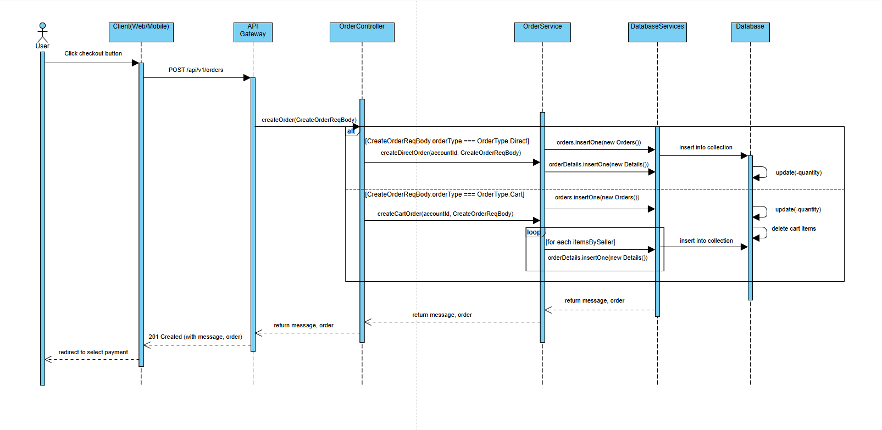

***3.1.2 Sequence Diagram Seller Create BlindBoxes***

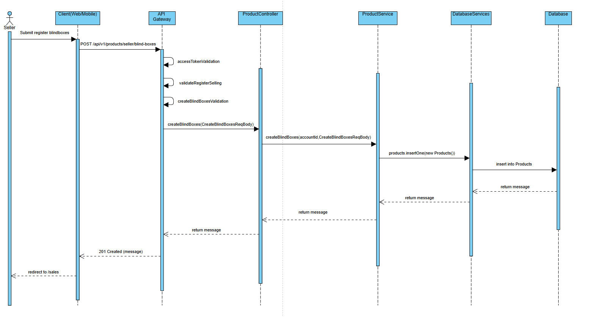

***3.1.2 Sequence Diagram Post Trade***

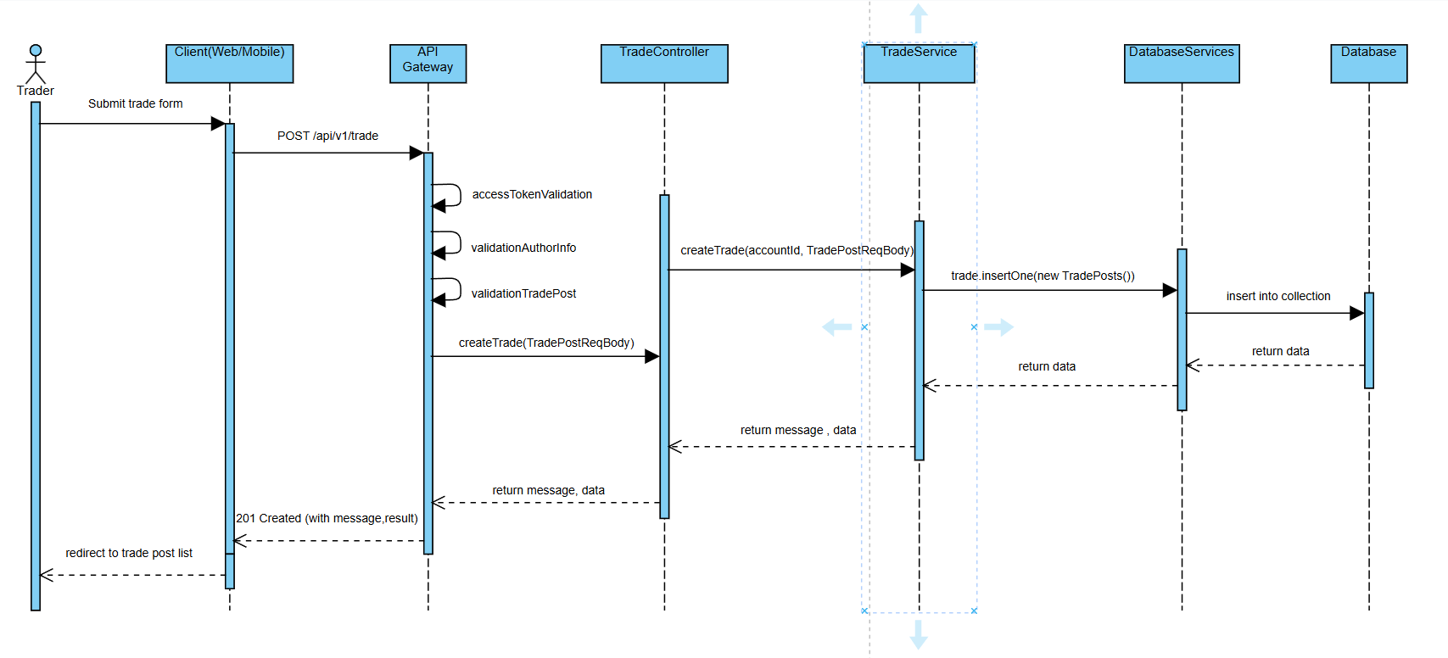

***3.1.2 Sequence Diagram Propose Trade***

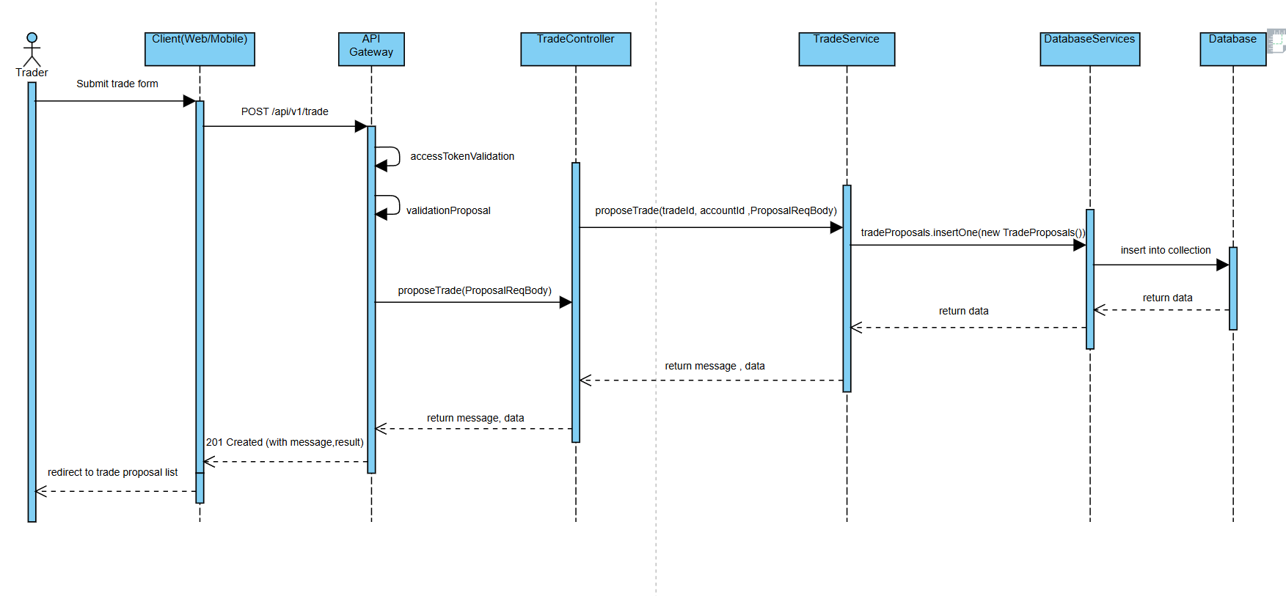

***3.1.3 State Diagram Buy & Sell (Phước)***

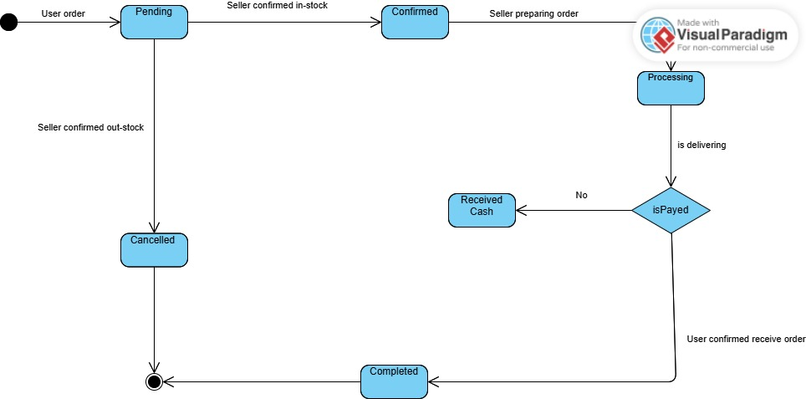

***3.1.3 State Diagram Trade***

